Chapter 2

More Image Restoration and Image Inpainting

Introduction

Image restoration and inpainting are crucial tasks in image processing and computer vision, aimed at recovering degraded or missing parts of an image. Restoration techniques enhance image quality by removing noise, correcting blur, and reconstructing lost information, while inpainting focuses on filling in missing or damaged regions in a visually plausible manner.

In this chapter, we shall continue with image restoration, focusing on solving image inpainting problems, using both traditional and deep learning based approaches. As explained in *Chapter 1, Image Restoration and Inverse Problems in Image Processing*, inpainting is a conservation process where damaged, missing, or corrupted parts of an image are filled/replaced. We shall learn how to use variational methods to solve image inpainting problems. However, our main focus in this chapter will be to use recent advanced deep learning models, such as autoencoders and GANs, to solve image denoising and inpainting problems.

Structure

In this chapter, we will go over the following topics:

* Denoising with autoencoders
* Blind deblurring with DeblurGAN
* Image inpainting
* Image denoising with anisotropic diffusion with opencv-python
* Simple deep image painting with Keras
* Semantic image inpainting with DCGAN

Objectives

By the end of this chapter, the reader will have a deeper understanding of various image restoration and inpainting techniques to recover degraded images and reconstruct missing regions. You will explore denoising with autoencoders, blind deblurring using DeblurGAN, and different inpainting methods. Additionally, you will gain hands-on experience with anisotropic diffusion-based denoising in opencv-python, deep image inpainting with Keras, and semantic inpainting using **Deep Convolutional Generative Adversarial Network** (**DCGAN**). These techniques will equip you with the skills to effectively restore and enhance images for practical applications in computer vision.

Denoising with autoencoders

An autoencoder is a neural network that learns a representation of input data (using its hidden layers $h_{W,b}\left(x\right)≈x$) in an unsupervised manner. In other words, it learns an approximation to the identity function so that the output $\hat{x}$ is similar to the input $x$ (as shown in *Figure 2.1*). By placing constraints on the network, for example, by having a much smaller number of hidden units (than the input), we can discover interesting structures in the input data (for example, learn a compressed representation in the hidden units and then reconstruct the output). Refer to the following figure:

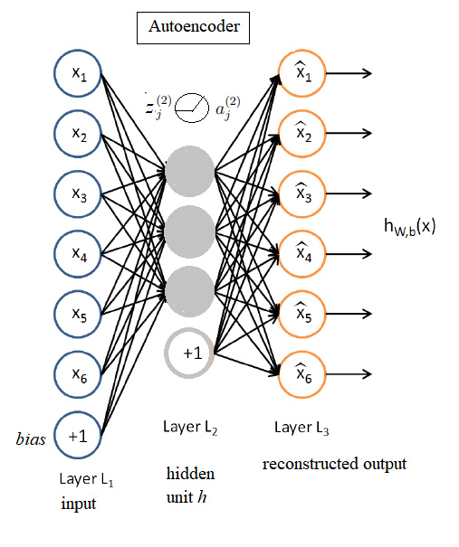

**Figure 2.1**: Basic architecture of an autoencoder

A **denoising autoencoder** is a stochastic version of an autoencoder that takes inputs corrupted by noise and then trained to recover the original inputs to learn a good representation. We can use denoising autoencoders to learn robust representations from similar input images (corrupted with noise) and then generate the denoised images.

Sparse denoising autoencoder

In sparse autoencoder, a **sparsity constraint** is imposed on the hidden units and the autoencoder is trained to discover interesting structure in the input. When the output value of a hidden neuron is close to $1$, it can be considered to be active (firing). On the contrary, if its output value is close to $0$, it is considered inactive. The constraint is to keep the hidden neurons inactive most of the time. If $a_{j}^{\left(2\right)}\left(x\right)$ denotes the activation of the $j^{th}$ hidden unit when the network is given a specific input $x$ and the average activation of hidden unit $j$ is denoted by ${\hat{ρ}}_{j}=\frac{1}{m}\sum_{i=1}^{m}{a_{j}^{\left(2\right)}x^{\left(i\right)}}$, then the constraint enforced is ${\hat{ρ}}_{j}=ρ$, where the hyperparameter $ρ$ represents *sparsity*. It is typically assigned to a very small value close to $0$ (for example, $ρ=0.05$).

In order to satisfy the sparsity constraint, the majority of the hidden unit’s activations must be around $0$ and thus an extra penalty term is added to the optimization objective function that penalizes ${\hat{ρ}}_{j}$ deviating significantly from $ρ$. For example, the following **Kullback-Leibler** (**KL**) divergence term for each hidden unit $j$:

$$KL\left(ρ||{\hat{ρ}}_{j}\right)=ρlog\frac{ρ}{{\hat{ρ}}_{j}}+\left(1-ρ\right)log\frac{1-ρ}{1-{\hat{ρ}}_{j}}$$

This penalty function has the property that $KL\left(ρ||{\hat{ρ}}_{j}\right)=0$ minimum when ${\hat{ρ}}_{j}=ρ$. Otherwise, it increases monotonically as ${\hat{ρ}}_{j}$ diverges from $ρ$. Hence, when this penalty term is minimized, it will force ${\hat{ρ}}_{j}$ to be close to $ρ$. The overall cost function is:

$$J_{sparse}\left(W,b\right)=J\left(W,b\right)+β\sum_{j=1}^{s_{2}}{KL\left(ρ||{\hat{ρ}}_{j}\right)}$$

Here, $s_{2}$ is the size of the hidden layer $L_{2}$ (number of hidden units) and $W$, $b$ represents the weights and bias parameters that are learned with back-propagation of the loss, with $β$ being a hyperparameter controlling the penalty (sparsity) term’s weight.

In this section, we shall learn how to implement a **sparse denoising autoencoder** with tensorflow, starting with noisy version of notMNIST input images (of English alphabets) and recover the clean input images using the autoencoder.

As usual, let us start by importing the required Python libraries. Note that we shall use the features of tensorflow v1 and disable the eager execution for v2.

import tensorflow as tf  
print(tf.__version__)  
*# 2.6.0*  
tf.compat.v1.disable_eager_execution()  
import math  
import matplotlib.pyplot as plt  
import os  
import numpy as np  
from cv2 import imread

Let us load the input notMNIST alphabet ($A-J$) images from the corresponding folder using the following function read_images(). Note that it searches all the png image files inside each of the $10$ subfolders (one for each alphabet), using os.walk() function, and stores the image and label (class) for each image found. Refer to the following code snippet:

def read_images(dataset_path = 'images/notmnist'):  
 images = []  
 labels = []  
 label = 0  
 classes = sorted(os.walk(dataset_path).__next__()[1])  
 for c in classes:  
 c_dir = os.path.join(dataset_path, c)  
 walk = os.walk(c_dir).__next__()  
 for sample in walk[2]:  
 if sample.endswith('.png'):  
 try:  
 image = imread(os.path.join(c_dir, sample), 0)  
 images.append(image.ravel())  
 labels.append(c)  
 except:  
 None  
 label += 1   
 images = np.asarray(images, dtype=np.uint8)  
 return images

The next function implements the KL divergence function, the penalty term to be added to the optimization cost function to ensure sparsity:

def kl_divergence(p, p_hat):  
 return p * tf.math.log(p) - p * tf.math.log(p_hat) + \  
 (1 - p) * tf.math.log(1 - p) - (1 - p) * tf.math.log(1 - p_hat)

Now, let us normalize the pixel values in the input images between $\left[0,1\right]$ and shuffle the images before starting training:

x_train = read_images()  
x_train = x_train / x_train.max()  
np.random.shuffle(x_train)

Let us set the hyperparameter values. Note that the number of hidden units in the single hidden layer $L_{2}$ is chosen to be $200$ and each input image is $28×28$. Hence, when flattened, the input dimension $n$ becomes $784$. Refer to the following code snippet:

p = 0.01  
learning_rate = 1e-3  
epochs = 40  
batch_size = 100  
reg_term_lambda = 2*1e-3  
beta = 3  
n = 784   
n_hidden = 200

Let us now dive into the core of the implementation, follow the next steps, to define the model:

* Let us define the tensorflow (v1) placeholders for the inputs (one for the original input $x$ and another one for the corrupted version $x_{noisy}$) / outputs ($\hat{x}$), and tensorflow variables to store the weight and bias parameters to be learned. Initialize the variables with tf.random.normal() function with appropriate arguments.
* Note that we have a couple of sets of weight parameters ($W_{1}$, $W_{2})$, one between the input and the hidden layer, and the other between the hidden and the output layer. The same is true for the bias parameters.
* Compute the forward propagation with matrix multiplications for both the hidden and output layers.
* Compute the average activation of hidden units $\hat{ρ}$.
* Compute the KL divergence penalty term $loss_{KL}$, to ensure the sparsity.
* Define the squared loss function for reconstruction. Note that the loss function uses the reconstruction error of the original image $x$ and not the noisy input, that is, $loss_{MSE}={\left(x-\hat{x}\right)}^{2}$
* Add $L_{2}$ regularization on the weights (to prevent overfitting) $reg_{L_{2}}\left(W\right)$ with the cost function.
* Add an additional penalty term as the KL divergence $loss_{KL}$.
* The cost function is the sum of the above $3$ functions: $loss=loss_{MSE}+reg_{L_{2}}+loss_{KL}$
* During forward pass, you need to compute $\hat{ρ}$ values so that you can compute the penalty term for sparsity.
* Note that we are using Adam optimizer here (for updating the parameters with backpropagation).

Refer to the following code snippet:

x = tf.compat.v1.placeholder(tf.float32, [None, n])  
x_noisy = tf.compat.v1.placeholder(tf.float32, [None, n])  
xhat= tf.compat.v1.placeholder(tf.float32, [None, n])  
  
W1 = tf.Variable(tf.random.normal([n, n_hidden], stddev=0.03), name='W1')  
b1 = tf.Variable(tf.random.normal([n_hidden]), name='b1')  
  
W2 = tf.Variable(tf.random.normal([n_hidden, n], stddev=0.03), name='W2')  
b2 = tf.Variable(tf.random.normal([n]), name='b2')  
  
linear_layer_one_output = tf.add(tf.matmul(x_noisy, W1), b1)  
layer_one_output = tf.nn.sigmoid(linear_layer_one_output)  
  
linear_layer_two_output = tf.add(tf.matmul(layer_one_output,W2),b2)  
xhat = tf.nn.sigmoid(linear_layer_two_output)  
  
mse_loss = (xhat - x)**2  
  
p_hat = tf.reduce_mean(tf.clip_by_value( \  
 layer_one_output,1e-10,1.0),axis=0)  
kl = kl_divergence(p, p_hat)  
  
cost = tf.reduce_mean(tf.reduce_sum(mse_loss, axis=1)) + \  
 reg_term_lambda*(tf.nn.l2_loss(W1) + tf.nn.l2_loss(W2)) + \  
 beta*tf.reduce_sum(kl)  
optimiser = tf.compat.v1.train.AdamOptimizer(learning_rate=learning_rate,\   
 beta1=0.9, beta2=0.999, epsilon=1e-08).minimize(cost)  
init_op = tf.compat.v1.global_variables_initializer()

Let us go over the following steps now, to instantiate the model, train it on the dataset:

1. Train the model. Let us run training epochs (for example, run for $40$ epochs) inside a session created with tf.compat.v1.Session(), using the following code snippet.
2. The session allows the execution of graphs or part of graphs. It allocates resources for this purpose and holds the actual values of intermediate results and variables.
3. Iterate over the batches, and each time fetch batch_size=100 images from the training dataset with x_train[cur:cur+batch_size].
4. Add random Gaussian noise (with np.random.normal() function) to corrupt the input images ($x$) and the (current) batch with noise standard deviation $0.15$ (try changing this), $x_{noisy}=x+noise$.
5. Note that you need to pass both $x$ and $x_{noisy}$ batch values to tensorflow session.run() graph computation’s feed_dict, for the corresponding placeholders.
6. Compute the loss function value (averaged across the batches) for every epoch and store in in the list losses.
7. Obtain the weights learned so far, with W1.eval(session).
8. Predict the denoised images ($\hat{x}$) with the model trained so far, with xhat.eval(session).

Refer to the following code snippet:

losses = []  
with tf.compat.v1.Session() as sess:  
 sess.run(init_op)  
 total_batch = int(len(y_train) / batch_size)  
 cur = 0  
 for epoch in range(epochs):  
 mean_cost = 0  
 for i in range(total_batch):  
 batch_x = x_train[cur:cur+batch_size]   
 noise = np.random.normal(0, 0.15, batch_x.shape)  
 batch_x_noisy = batch_x + noise  
 _, c = sess.run([optimiser, cost], \  
 feed_dict={x: batch_x, x_noisy: batch_x_noisy})  
 mean_cost += c / total_batch  
 losses.append(mean_cost)  
 if((epoch + 1) % 10 == 0):  
 input_images = batch_x  
 noisy_image = batch_x_noisy  
 weight_images = W1.eval(sess).transpose()  
 output_images = xhat.eval(feed_dict={x: batch_x, \  
 x_noisy: batch_x_noisy}, session=sess)  
 *# TODO: plot images here*  
 cur += batch_size

As can be seen from the preceding code snippet, you can plot the training progress (expected decrease in loss function value) and visualize the original and denoised images (obtained with model prediction), the code for plotting is left as an exercise (fill-in the *TODO* section before):

* Plot the loss function values to see the decay over epochs (left as an exercise, insert your code at line $20$ in the preceding code snippet. The following *Figure 2.2* shows the output that you could see after 40 epochs:

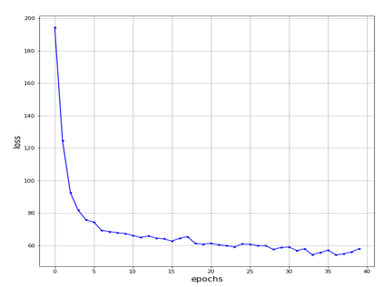

**Figure 2.2**: Decay of the loss function value over epochs

* Plot the original and noisy inputs, the weights learned, and the denoised output (for example, every 10 epochs). You should obtain a figure like the following one:

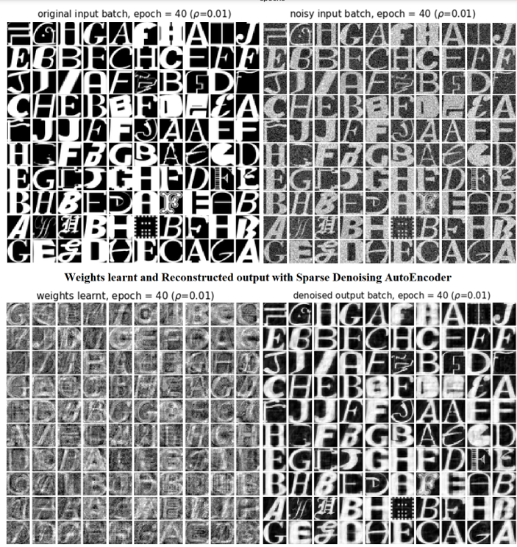

**Figure 2.3**: Denoising notMNIST images with sparse denoising autoencoder

Denoising with convolution autoencoder with skip connection

In this problem, you will learn to use a very deep fully convolutional **R**esidual **E**ncoder-**D**ecoder Neural **N**etwork, also called **RED-Net**, for image denoising and restoration. The network is composed of multiple convolution and transposed-convolution layers, enabling it to learn end-to-end mappings from corrupted images (provided as input) to denoised original images (to be produced as output). The convolution layers eliminate corruptions by capturing the abstraction of image contents. Transposed-convolutional layers recover the image details by up-sampling the feature maps [1].

To avoid difficulty in training, convolutional and transposed-convolutional layers are symmetrically linked with skip-layer connections (as shown in the following *Figure 2.4*), to get the training converge faster with better results:

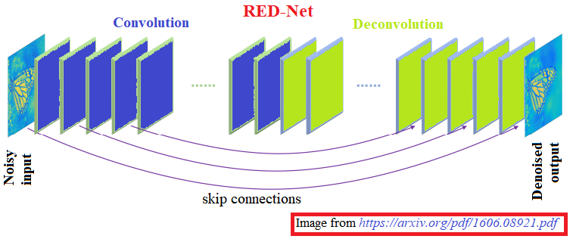

**Figure 2.4**: RED-Net architecture

**Source:** https://arxiv.org/pdf/1606.08921.pdf

The skip connections from convolutional layers to their mirrored corresponding transposed-convolutional layers exhibit the following couple of advantages:

* It handles the vanishing gradient problem while back-propagation.
* The skip connections pass image details from convolutional layers to transposed-convolutional layers, which is beneficial in recovering the clean image.

Again, we shall implement the deep learning model with tensorflow, and this time, we shall use the keras library functions. Let us start by importing the required libraries:

import tensorflow as tf  
from keras import layers, models, initializers  
import numpy as np  
import cv2  
import matplotlib.pyplot as plt

Let us go over the following, as a detailed guidance for a step-by-step implementation:

1. In general, there are the following layers in the network: convolution (Conv2D), transposed-convolution (Conv2DTranspose) and element-wise sum (Add). Each layer is followed by a **Rectified Linear Unit** (ReLU).
2. An additional layer BatchNormalization is added. It applies a transformation that maintains the mean output close to $0$ and the output standard deviation close to $1$. The layer will only normalize its inputs during inference after being trained on data with similar statistics to the inference data and tackles the internal covariate shift problem.
3. For the element-wise sum layer, the output is the element-wise sum of two inputs.
4. Learning the end-to-end mapping from corrupted images to clean images needs to estimate the weights $Θ$ represented by the convolutional and transposed-convolutional kernels.
5. Convolution layers work as feature extraction units, preserving the image's details and eliminating the corruption. After a forward pass through the convolutional layers, the corrupted input gets converted into a clean one, although subtle details may be lost. The transposed-convolutional layers are then combined to recover the details, outputting the recovered clean version. Moreover, skip connections from a convolutional layer to its corresponding mirrored transposed -convolutional layer are added. The passed convolutional feature maps are summed to the transposed-convolutional feature maps element-wise and passed to the next layer after rectification.
6. Depth of the network used for image denoising varies from $20$ and $30$ layers (implemented with a for loop, by adding group of layers iteratively, as done in the next code snippet, with the rednet() function which returns a model of the specified depth as input argument and the number of filters for filters for the convolution/transposed-convolution layers, defaulting to $128$).
7. Note that transposed-convolution is sometimes (wrongly) called deconvolution, since deconvolution implies removing the effect of convolution, which is not the goal here. It is also known as upsampled convolution, which is intuitive to the task it is used to perform, that is, upsample the input feature map.

Refer to the following code sample:

def rednet(depth=20, n_filters=128, kernel_size=(3, 3), \  
 skip_step=2, n_channels=1):  
  
 num_connections = np.ceil(depth / (2 * skip_step)) \  
 if skip_step > 0 else 0  
 x = layers.Input(shape=[None, None, n_channels], name="InputImage")  
 y = x  
 encoder_layers = []  
  
 with tf.name_scope("REDNet"):  
  
 for i in range(depth // 2):  
 with tf.name_scope("EncoderLayer{}".format(i + 1)):  
 y = layers.Conv2D(n_filters, kernel_size=kernel_size, \  
 kernel_initializer=initializers.glorot_uniform(),\  
 padding="same", activation=None, use_bias=False,  
 name="Layer{}_Conv".format(i + 1))(y)  
 y = layers.BatchNormalization(name="Layer{}_BatchNorm" \  
 .format(i + 1))(y)  
 y = layers.ReLU(name="Layer{}_Actv".format(i + 1))(y)  
 encoder_layers.append(y)  
  
 j = int((num_connections - 1) * skip_step) *# Encoder layers count*  
 k = int(depth-(num_connections-1)*skip_step) *# Decoder layers cnt*  
 for i in range(depth // 2 + 1, depth):  
 with tf.name_scope("DecoderLayer{}".format(i + 1)):  
 y = layers.Conv2DTranspose(n_filters, \  
 kernel_size=kernel_size, \  
 kernel_initializer=initializers.glorot_uniform(), \  
 padding="same", activation=None, use_bias=False, \   
 name="Layer{}_Conv".format(i))(y)  
 y = layers.BatchNormalization(name="Layer{}_BatchNorm"\  
 .format(i))(y)  
 if i == k:  
 y = layers.Add(name="SkipConnect_Enc_{}_Dec_{}"\  
 .format(j, k))([encoder_layers[j - 1], y])  
 k += skip_step  
 j -= skip_step  
 y = layers.ReLU(name="Layer{}_Actv".format(i))(y)  
  
 with tf.name_scope("OutputLayer"):  
 y = layers.Conv2DTranspose(1, kernel_size=kernel_size, \  
 kernel_initializer=initializers.glorot_uniform(), \  
 padding="same", activation=None, use_bias=False, \  
 name="Output_Conv")(y)  
 y = layers.BatchNormalization(name="Output_BatchNorm")(y)  
 y = layers.Add(name="SkipConnect_Input_Output")([x, y])  
 y = layers.ReLU(name="Output_Actv")(y)  
 return models.Model(inputs=[x], outputs=[y])  
  
rednet30 = rednet(30, n_channels=3)

Next, create a noisy input dataset by following the next steps:

1. Let us use the CIFAR10 image dataset (available in tf.keras.datasets), add noise to the images and denoise it using RED-Net.
2. Load the training and test datasets using the load_data() function and normalize the pixel values, using the following code block:

(x_train, y_train), (x_test, y_test) = tf.keras.datasets.cifar10.load_data()  
x_train = x_train / 255  
x_test = x_test / 255  
np.random.shuffle(x_train)  
noise = np.zeros(x_train.shape)  
for i in range(x_train.shape[-1]):  
 noise[..., i] = np.random.normal(0, 0.1, size=x_train.shape[:-1])  
x_train_noisy = x_train + noise  
noise = np.zeros(x_test.shape)  
for i in range(x_test.shape[-1]):  
 noise[..., i] = np.random.normal(0, 0.1, size=x_test.shape[:-1])  
x_test_noisy = x_test + noise

Now, compile the model and run training (using fit() on the noisy and clean training images) for $10$ epochs. Train on a **GPU** (use Google Colab) for faster training, on CPU it will be slow. Refer to the following code snippet:

rednet30.compile(  
 optimizer=tf.keras.optimizers.Adam(learning_rate=5*1e-6), *# Optimizer*  
 loss=tf.keras.losses.binary_crossentropy  
)  
  
history = rednet30.fit(  
 x_train_noisy,  
 x_train,  
 batch_size=64,  
 epochs=10)

Plot the decaying loss from the history, using the following code snippet:

plt.plot(range(len(history.history['loss'])), history.history['loss'])  
plt.grid()  
plt.xlabel('Epochs', size=10)  
plt.ylabel('Loss', size=10)  
plt.show()

If you run the preceding code snippet, you should obtain a figure like the next one:

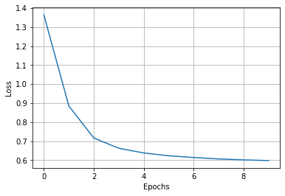

**Figure 2.5**: Learning over epochs

Predict to restore the clean images from the noisy test images:

x_test_p = rednet30.predict(x_test_noisy)

Choose a random sample of $10$ noisy test images, denoise them with RED-Net. Plot the noisy along with the recovered images. You should obtain a figure as follows:

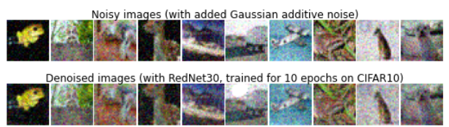  
**Figure 2.6**: Denoising images from CIFRA10 dataset with RED-Net

Deraining with GCANet

In this problem, we shall focus on deraining an image using *a pre-trained* deep learning model (dehazing network), that is, the input will be an image in a rainy environment and the output will be one without the rain-streak component. Given a hazy input image, the dehazing network tries to retrieve the uncorrupted content. Again, instead of using traditional handcrafted or low-level image priors as the constraints for handcrafted, the output haze-free image will be directly restored using an end-to-end deep neural net named **Gated Context Aggregation Network** (**GCANet**). In this network, the latest smoothed dilation technique is used to get rid of the gridding artifacts caused due to the dilated convolution, and a gated sub-network will be used to fuse the features from different levels. The following *Figure 2.7* shows the architecture of the deep neural net [3]:

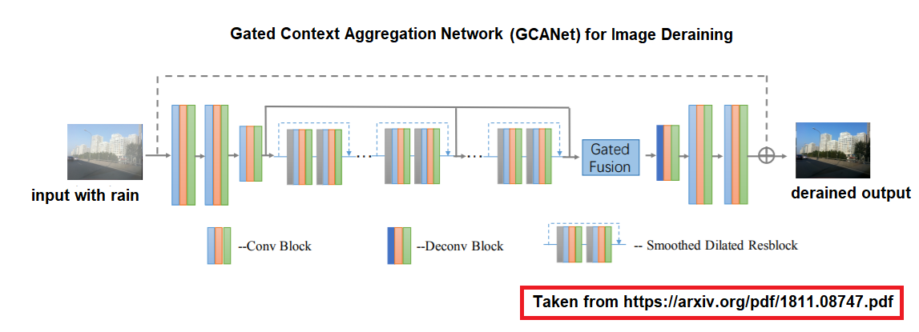

**Figure 2.7**: GCANet architecture

Let us understand how this model works:

* Using the encoder, a hazy input image is encoded into the feature maps. Next, more context information is aggregated, and features from different levels are fused (without downsampling) to enhance the feature maps.
* Smoothed dilated convolution (implemented using dilated convolutional layer) and an extra gated sub-network are used.
* The target haze residue is computed after decoding the enhanced feature maps back to original image space. Next, the residue obtained is added to the hazy input image, and the final haze-free image is obtained.
* The feature maps from different levels $F_{l},F_{m},F_{h}$ are extracted and fed into the gated fusion subnetwork. Three different importance weights, namely, ($M_{l},M_{m},M_{h}$) are output by the gated fusion sub-network (corresponding to the three feature levels, respectively). Finally, the regressed importance weights obtained are used to (linearly) combine these three feature maps from different levels.

Let us implement the model, this time using PyTorch. Start by importing the libraries needed:

import torch  
import torch.nn as nn  
import torch.nn.functional as F  
from torch.autograd import Variable  
import numpy as np  
from PIL import Image  
import os

Let us deep dive into the core of the implementation using the following code snippet uses the original GCANet implementation [8].

* The class SmoothDilatedResidualBlock in the next code block implements the smooth dilated ResBlock (**Residual Block**, a key component in deep neural networks that helps in training very deep models by using **skip connections** to mitigate the **vanishing gradient** problem) by stacking smooth dilated convolution blocks using the ShareSepConv class, ordinary convolution blocks (nn.Conv2d), and instance normalization blocks (nn.InstanceNorm2d, which computes the mean and standard deviation across each individual channel for a single example and implements instant-specific normalization).
* Note that all the classes inherit from torch.nn.Module and they implement a couple of methods:
  + __init__(): the constructor called upon the instantiation of the object, it defines the structure of the network and initializes the member variables.
  + forward(): this method is called to run a forward pass on the layers in the block.

Refer to the following code snippet:

class ShareSepConv(nn.Module):  
 def __init__(self, kernel_size):  
 super(ShareSepConv, self).__init__()  
 assert kernel_size % 2 == 1, 'kernel size should be odd!'  
 self.padding = (kernel_size - 1) // 2  
 weight_tensor = torch.zeros(1, 1, kernel_size, kernel_size)  
 weight_tensor[0, 0, (kernel_size - 1) // 2, \  
 (kernel_size - 1) // 2] = 1  
 self.weight = nn.Parameter(weight_tensor)  
 self.kernel_size = kernel_size  
  
 def forward(self, x):  
 inc = x.size(1)  
 expand_weight = self.weight.expand(inc, 1, self.kernel_size, \   
 self.kernel_size).contiguous()  
 return F.conv2d(x, expand_weight, None, 1, self.padding, 1, inc)  
  
  
class SmoothDilatedResidualBlock(nn.Module):  
 def __init__(self, num_channels, dilation=1, groups=1):  
 super(SmoothDilatedResidualBlock, self).__init__()  
 self.pre_conv1 = ShareSepConv(dilation*2 - 1)  
 self.conv1 = nn.Conv2d(num_channels, num_channels, 3, 1, \  
 padding=dilation, dilation=dilation, groups=groups, bias=False)  
 self.norm1 = nn.InstanceNorm2d(num_channels, affine=True)  
 self.pre_conv2 = ShareSepConv(dilation*2 - 1)  
 self.conv2 = nn.Conv2d(num_channels, num_channels, 3, 1, \   
 padding=dilation, dilation=dilation, groups=groups, bias=False)  
 self.norm2 = nn.InstanceNorm2d(num_channels, affine=True)  
  
 def forward(self, x):  
 y = F.relu(self.norm1(self.conv1(self.pre_conv1(x))))  
 y = self.norm2(self.conv2(self.pre_conv2(y)))  
 return F.relu(x+y)  
  
class ResidualBlock(nn.Module):  
 def __init__(self, num_channels, dilation=1, groups=1):  
 super(ResidualBlock, self).__init__()  
 self.conv1 = nn.Conv2d(num_channels, num_channels, 3, 1, \   
 padding=dilation, dilation=dilation, \  
 groups=groups, bias=False)  
 self.norm1 = nn.InstanceNorm2d(num_channels, affine=True)  
 self.conv2 = nn.Conv2d(num_channels, num_channels, 3, 1, \   
 padding=dilation, dilation=dilation, \  
 groups=groups, bias=False)  
 self.norm2 = nn.InstanceNorm2d(num_channels, affine=True)  
  
 def forward(self, x):  
 y = F.relu(self.norm1(self.conv1(x)))  
 y = self.norm2(self.conv2(y))  
 return F.relu(x+y)

The class GCANet implements the GCANet architecture. As shown in *Figure 2.7*, the network first uses a bunch of convolution layers, followed by a bunch of SmoothDilatedResidualBlock layers, followed by a ResidualBlock, and finally a transposed convolution (nn.ConvTranspose2d) block, followed by a bunch of convolution blocks.

class GCANet(nn.Module):  
 def __init__(self, in_c=4, out_c=3, only_residual=True):  
 super(GCANet, self).__init__()  
 self.conv1 = nn.Conv2d(in_c, 64, 3, 1, 1, bias=False)  
 self.norm1 = nn.InstanceNorm2d(64, affine=True)  
 self.conv2 = nn.Conv2d(64, 64, 3, 1, 1, bias=False)  
 self.norm2 = nn.InstanceNorm2d(64, affine=True)  
 self.conv3 = nn.Conv2d(64, 64, 3, 2, 1, bias=False)  
 self.norm3 = nn.InstanceNorm2d(64, affine=True)  
  
 self.res1 = SmoothDilatedResidualBlock(64, dilation=2)  
 self.res2 = SmoothDilatedResidualBlock(64, dilation=2)  
 self.res3 = SmoothDilatedResidualBlock(64, dilation=2)  
 self.res4 = SmoothDilatedResidualBlock(64, dilation=4)  
 self.res5 = SmoothDilatedResidualBlock(64, dilation=4)  
 self.res6 = SmoothDilatedResidualBlock(64, dilation=4)  
 self.res7 = ResidualBlock(64, dilation=1)  
  
 self.gate = nn.Conv2d(64 * 3, 3, 3, 1, 1, bias=True)  
   
 self.deconv3 = nn.ConvTranspose2d(64, 64, 4, 2, 1)  
 self.norm4 = nn.InstanceNorm2d(64, affine=True)  
 self.deconv2 = nn.Conv2d(64, 64, 3, 1, 1)  
 self.norm5 = nn.InstanceNorm2d(64, affine=True)  
 self.deconv1 = nn.Conv2d(64, out_c, 1)  
 self.only_residual = only_residual  
  
 def forward(self, x):  
 y = F.relu(self.norm1(self.conv1(x)))  
 y = F.relu(self.norm2(self.conv2(y)))  
 y1 = F.relu(self.norm3(self.conv3(y)))  
 y = self.res1(y1)  
 y = self.res2(y)  
 y = self.res3(y)  
 y2 = self.res4(y)  
 y = self.res5(y2)  
 y = self.res6(y)  
 y3 = self.res7(y)  
  
 gates = self.gate(torch.cat((y1, y2, y3), dim=1))  
 gated_y = y1 * gates[:,[0],:,:] + y2 * gates[:, [1], :, :] + \  
 y3 * gates[:, [2], :, :]  
 y = F.relu(self.norm4(self.deconv3(gated_y)))  
 y = F.relu(self.norm5(self.deconv2(y)))  
 if self.only_residual:  
 y = self.deconv1(y)  
 else:  
 y = F.relu(self.deconv1(y))  
  
 return y

Along with the input image, if the pre-calculated edges in the input image are fed as auxiliary information to the network, it often turns out to be very helpful to the network learning. For this purpose, the function edge_compute() pre-computes the edges from the image.

def edge_compute(x):  
 x_diffx = torch.abs(x[:,:,1:] - x[:,:,:-1])  
 x_diffy = torch.abs(x[:,1:,:] - x[:,:-1,:])  
 y = x.new(x.size())  
 y.fill_(0)  
 y[:,:,1:] += x_diffx  
 y[:,:,:-1] += x_diffx  
 y[:,1:,:] += x_diffy  
 y[:,:-1,:] += x_diffy  
 y = torch.sum(y,0,keepdim=True)/3  
 y /= 4  
 return y

Let us understand how to instantiate the model, load the pretrained weights and run inference on the model, with a step-by-step explanation of the next code snippet:

1. Instantiate the GCANet into the variable net and load the pretrained model weights using the method torch.load(). Then set the network to evaluation mode with net.eval(), and it is ready for prediction.
2. Read the rainy input image (with PIL open() method). The image size is assumed to be a multiple of $4$. If it is not, it is resized accordingly.
3. Concatenate (using torch.cat()) the pre-calculated edges (using edge_compute()) with the hazy input image along the channel dimension to obtain the final input to the model.
4. Compute numpy narray to pytorch tensor (with torch.from_numpy()) and back (using .numpy()) as and when required.
5. torch.no_grad() deactivates autograd engine, by setting all of the requires_grad flags to False temporarily.
6. Run a forward pass on the neural net (using net()) to predict the derained output image.
7. Plot the input and output derained image using the following code snippet:

*#task = 'derain'*  
model = 'models/wacv_gcanet_derain.pth'   
  
net = GCANet(in_c=4, out_c=3, only_residual=False)  
net.float()  
net.load_state_dict(torch.load(model, map_location='cpu'))  
net.eval()  
  
img_path = 'images/Img_02_03.jpg'  
img = Image.open(img_path).convert('RGB')  
im_w, im_h = img.size  
if im_w % 4 != 0 or im_h % 4 != 0:  
 img = img.resize((int(im_w // 4 * 4), int(im_h // 4 * 4)))   
img = np.array(img).astype('float')  
  
img_data = torch.from_numpy(img.transpose((2, 0, 1))).float()  
edge_data = edge_compute(img_data)  
in_data = torch.cat((img_data, edge_data), dim=0)\  
 .unsqueeze(0) - 128   
in_data = in_data.float()  
  
with torch.no_grad():  
 pred = net(Variable(in_data))  
out_img_data = pred.data[0].cpu().float().round().clamp(0, 255)  
out_img = Image.fromarray(out_img_data.numpy().astype(np.uint8)\  
 .transpose(1, 2, 0))  
  
plt.figure(figsize=(12,10))  
plt.subplots_adjust(0,0,1,0.95,0.05,0.05)  
plt.subplot(121), plt.imshow(img.astype(int)), plt.axis('off') plt.title('original', size=20)  
plt.subplot(122), plt.imshow(out_img), plt.axis('off') plt.title('derained', size=20)  
plt.show()

If you run the preceding code snippet, you should obtain a figure as follows:

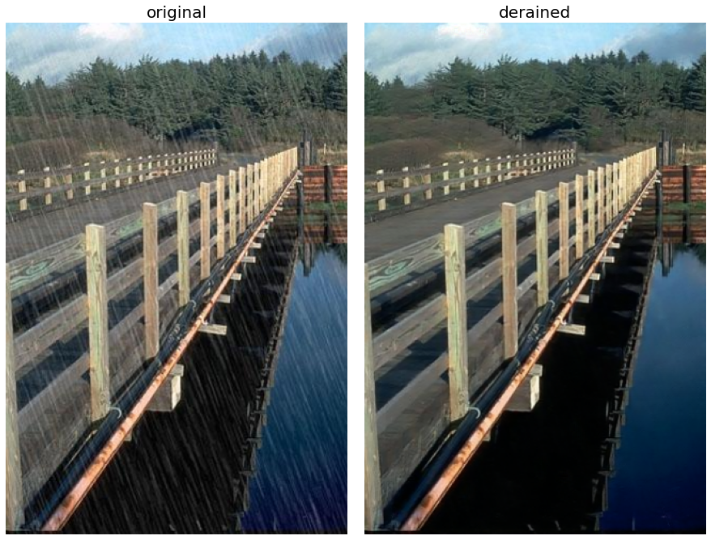

**Figure 2.8**: Deraining with pretrained GCANet

Blind deblurring with DeblurGAN

In this section, we shall learn how to solve blind motion deblurring of a single photograph using an end-to-end generative deep learning model called **DeblurGAN**. The learning is based on a conditional**Generative Adversarial Network** (**GAN**) and content loss. As described in *Chapter 1, Image Restoration and Inverse Problems in Image Processing,* the family of deblurring problems is divided into two types: blind and non-blind deblurring, without and with an assumption that the blur kernel is known, respectively. When the blur function is unknown, and blind deblurring algorithms estimate both latent sharp image and blur kernel (as Richardson-Lucy algorithm, implemented in *Chapter 1, Image Restoration and Inverse Problems in Image Processing*).

GAN, a form of unsupervised machine learning, trains two competing networks, namely, the discriminator and the generator simultaneously, as shown in *Figure 2.9*. Their roles are:

* The generator $G$ receives noise as an input and generates a sample. The goal of the generator is to fool the discriminator by generating perceptually convincing samples that can not be distinguished from the real one.
* The discriminator $D$ receives a real and generated (fake) sample and tries to distinguish between them. The goal of the discriminator is to detect the fake image generated, it learns a binary classifier, outputing $1$ when the input is a real image and $0$ in case of a fake one.

Refer to the following figure:

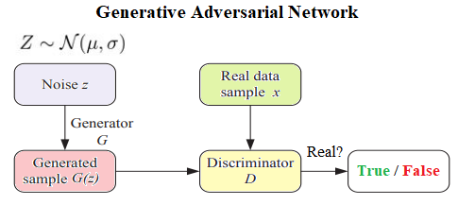

**Figure 2.9**: Schematic diagram of a generative adversarial network

If $x$ be a real image and $\tilde{x}$ be a fake image generated by $G$ (from noise $z$, by $\tilde{x}=G\left(z\right)$),

* The discriminator $D$ tries to maximize $D\left(x\right)$ and minimize $D\left(\tilde{x}\right)$ (or equivalently maximize $1-D\left(\tilde{x}\right)$) to detect *fake* images generated by $G$.
* The generator $G$ tries to maximize $D\left(\tilde{x}\right)$ (or equivalently minimize $1-D\left(\tilde{x}\right)$) to fool $D$.

Hence, the game between the generator $G$ and discriminator $D$ then can be formulated by the following minimax objective (in the $log​$ space), also called **adversarial loss**:

$$\min_{G} \max_{D} E_{x∼P_{r}}\left[log\left(D\left(x\right)\right)\right]+E_{\tilde{x}∼P_{g}}\left[log\left(1-D\left(\tilde{x}\right)\right)\right]$$

Where, $P_{r}$ is the data distribution and $P_{g}$ is the model distribution, defined by $\tilde{x}=G\left(z\right)$. The input $z$ is a sample from a simple noise distribution and $G\left(z\right)$ is the (fake) image output by the generator-given input $z$. $D\left(x\right)$ is the discriminator’s estimate of the probability that real data instance $x$ is real. GANs are known for their ability to generate samples of good perceptual quality.

**Conditional GAN** (**cGAN**) is an extension of the GAN framework. An additional conditional information $C$ is input to both discriminator and generator (as shown in *Figure 2.10*) that describes some aspect of the images (for example, if it is MNIST images, $C$ could describe the digit class/label). This attribute information is inserted in both the generator and the discriminator. Hence, when the adversarial training is over, the generator can generate a digit of a specific class when asked. Unlike vanilla GAN, cGAN learns mapping from observed image $x$ and random noise vector $z$ to $y$, $G:x,z→y$.

The goal of DeblurGAN is to recover sharp image $I_{S}$ given only a blurred image $I_{B}$ as an input, without any information about the blur kernel. Debluring is done by the trained CNN $G_{θ_{G}}$, which acts as the generator. For each $I_{B}$ it estimates the corresponding $I_{S}$ image. In addition, during the training phase, the critic network $D_{θ_{D}}$ is introduced, and both networks are trained in an adversarial manner. The loss function is formulated as a combination of content and adversarial loss:

$$L= \underset{total loss}{\underbrace{\underset{ adversarial loss}{\underbrace{ L_{GAN }}}+\underset{content loss }{λ\underbrace{{ L}_{χ} }}}}$$

The following figure shows the architecture of the generator network $G$:

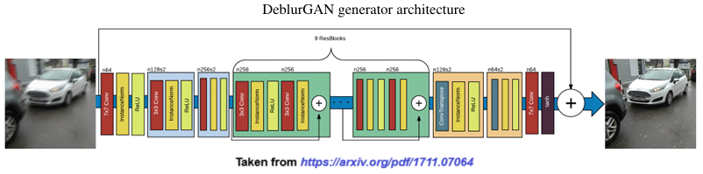

**Figure 2.10**: Generator architecture in DeblurGAN

As can be seen from the preceding figure, it contains two strided convolution blocks with stride 1 or 2, nine residual blocks (ResBlocks) and two transposed convolution blocks. Each ResBlock consists of a convolution layer, instance normalization layer, and ReLU activation. Dropout regularization with a probability of $0.5$ is added after the first convolution layer in each ResBlock. In addition, a global skip connection, referred to as ResOut, is introduced CNN learns a residual correction $I_{R}$ to the blurred image $I_{B}$, so $I_{S}=I_{B}+I_{R}$. It is found that such formulation makes training faster and resulting model generalizes better [2].

Let us start our implementation by importing all the required libraries, using the following code block.

import tensorflow as tf  
from tensorflow.keras.layers import Input, Conv2D, Activation, Add, \   
 UpSampling2D, BatchNormalization, Dropout  
from tensorflow.keras.layers import LeakyReLU, Conv2D, Dense, Flatten, \  
 Lambda, InputSpec, Layer  
from tensorflow.keras.models import Model  
import tensorflow.keras.utils as conv_utils  
import tensorflow.keras.backend as K  
from PIL import Image  
import numpy as np  
import matplotlib.pylab as plt  
from glob import glob

Let us go through the following python implementation steps, accompanied by detailed explanation:

* Refer to the preceding network architecture. We are going to implement a slightly modified version of this network using keras.
* The function res_block() in the following code snippet instantiates a Keras Resnet block using **Keras functional API**. It accepts the following parameters: an input (tensor), number of filters, kernel size and shape of strides for the convolution, whether to use dropout or not and returns a Keras model. It uses couples of ReflectionPadding2D instances with an optional Dropout layer (to prevent overfitting) in the middle.
* The function normalize_tuple() transforms a single integer or iterable of integers into an integer tuple.
* Note that we are here, we are going to expect the input image only in the channels_last image data format (modify the code if you want to support other data formats), which is the same as K.image_data_format().

data_format = K.image_data_format()  
  
def res_block(input, filters, kernel_size=(3, 3), strides=(1, 1), \   
 dropout=False):  
   
 x = ReflectionPadding2D((1, 1))(input)  
 x = Conv2D(filters=filters, kernel_size=kernel_size, \   
 strides=strides)(x)  
 x = BatchNormalization()(x)  
 x = Activation('relu')(x)  
  
 if dropout:  
 x = Dropout(0.5)(x)  
  
 x = ReflectionPadding2D((1, 1))(x)  
 x = Conv2D(filters=filters, kernel_size=kernel_size, \   
 strides=strides,)(x)  
 x = BatchNormalization()(x)  
  
 merged = Add()([input, x])  
 return merged  
  
def normalize_tuple(value, n):   
 return (value,) * n if isinstance(value, int) else tuple(value)  
  
def spatial_reflection_2d_padding(x, padding=((1, 1), (1, 1))):  
 *#assert len(padding)==2 & len(padding[0])==2 & len(padding[1])==2*  
 pattern = [[0, 0], list(padding[0]), list(padding[1]), [0, 0]]  
 return tf.pad(x, pattern, "REFLECT")  
  
class ReflectionPadding2D(Layer):  
  
 def __init__(self, padding=(1, 1), **kwargs):  
 super(ReflectionPadding2D, self).__init__(**kwargs)  
 self.data_format = data_format  
 if isinstance(padding, int):  
 self.padding = ((padding, padding), (padding, padding))  
 elif hasattr(padding, '__len__'):  
 *# assert len(padding) == 2:*  
 height_padding = normalize_tuple(padding[0], 2)  
 width_padding = normalize_tuple(padding[1], 2)  
 self.padding = (height_padding, width_padding)  
   
 self.input_spec = InputSpec(ndim=4)  
  
 def compute_output_shape(self, input_shape):  
 rows = input_shape[1] + self.padding[0][0] + self.padding[0][1] \  
 if input_shape[1] is not None else None  
 cols = input_shape[2] + self.padding[1][0] + self.padding[1][1] \  
 if input_shape[2] is not None else None  
 return (input_shape[0], rows, cols, input_shape[3])  
  
 def call(self, inputs):  
 return spatial_reflection_2d_padding(inputs, padding=self.padding)  
  
 def get_config(self):  
 config = {'padding': self.padding,   
 'data_format': self.data_format}  
 base_config = super(ReflectionPadding2D, self).get_config()  
 return dict(list(base_config.items()) + list(config.items()))

Let us proceed to the next part:

* Now implement the generator model, using the preceding res_block. Note that the input shape of the image used here is hard coded to $\left(256,256,3\right)$, you may want to play with the size and observe the impact on the output.
* As shown in the model architecture diagram, the following implementation uses n_blocks_gen=9 res_blocks.
* Note that the res_blocks use dropout (use_dropout=True) to prevent overfitting.
* It uses BatchNormalization layer though instead of instance normalization (to see the difference, we have to change the network to use instance normalization instead and observe the impact).
* It uses UpSampling2D layer instead of Conv2DTranspose (find out the difference, left as an exercise).

n_blocks_gen = 9  
  
def generator_model():  
   
 inputs = Input(shape=(256, 256, 3))  
  
 x = ReflectionPadding2D((3, 3))(inputs)  
 x = Conv2D(filters=ngf, kernel_size=(7, 7), padding='valid')(x)  
 x = BatchNormalization()(x)  
 x = Activation('relu')(x)  
  
 n_downsampling = 2  
 for i in range(n_downsampling):  
 mult = 2**i  
 x = Conv2D(filters=ngf*mult*2, kernel_size=(3, 3), strides=2, \   
 padding='same')(x)  
 x = BatchNormalization()(x)  
 x = Activation('relu')(x)  
  
 mult = 2**n_downsampling  
 for i in range(n_blocks_gen):  
 x = res_block(x, ngf*mult, use_dropout=True)  
  
 for i in range(n_downsampling):  
 mult = 2**(n_downsampling - i)  
 x = UpSampling2D()(x)  
 x = Conv2D(filters=int(ngf * mult / 2), kernel_size=(3, 3), \   
 padding='same')(x)  
 x = BatchNormalization()(x)  
 x = Activation('relu')(x)  
  
 x = ReflectionPadding2D((3, 3))(x)  
 x = Conv2D(filters=output_nc, kernel_size=(7, 7), padding='valid')(x)  
 x = Activation('tanh')(x)  
  
 outputs = Add()([x, inputs])  
 outputs = Lambda(lambda z: z/2)(outputs)  
  
 model = Model(inputs=inputs, outputs=outputs, name='Generator')  
 return model

Let us go over the following points:

* Once the generator architecture is defined, we are ready to load the pretrained weights in the generator and run deblurring.
* The function **load_image()** in the following code snippet uses the PIL library method Image.open() to open load an image from disk, given its path.
* The function preprocess_image() normalizes the input image pixels (assuming that pixel values are in $\left[0,255\right]$).
* The function deprocesss_image() does the reverse operation: it converts normalized pixel values back into the range $\left[0,255\right]$ and changes the image type back to an 8-bit unsigned integer.
* The function deblur() accepts a couple of input parameters, the first one being the blurred image to be sharpened and the second one being the pre-trained DeblurGAN model that will be used to deblur the image. The function preprocesses the blurred input image, loads the pre-trained weights in the generator model, and uses the generator to predict the generated (de-blurred) image, deprocesses it, and returns it.
* Finally, load the original input image and its blurred version (you will be asked to implement a custom blur kernel to simulate a motion-blurred version on the input image). Invoke the deblur() function with the blurred image as an input argument to obtain the sharpened output in return.

def load_image(path):  
 img = Image.open(path)  
 return img  
  
def preprocess_image(img):  
 img = img.resize((256,256))  
 img = np.array(img)  
 img = (img - 127.5) / 127.5  
 return img  
  
def deprocess_image(img):  
 img = img * 127.5 + 127.5  
 return img.astype('uint8')  
  
def deblur(blurred, model_path):  
 x_test_lst = [preprocess_image(blurred)]  
 batch_size = len(x_test_lst)  
 x_test = np.array(x_test_lst)  
 g = generator_model()  
 g.load_weights(model_path)  
 generated_images = g.predict(x=x_test, batch_size=1)  
 generated = np.array([deprocess_image(img) \  
 for img in generated_images])[0]  
 return generated  
  
orig, blurred = load_image('images/Img_02_04.jpg'), \  
 load_image('images/Img_02_21.jpg')  
deblurred = deblur(blurred, 'models/generator.h5')

If you plot the original, blurred, and deblurred (with DeblurGAN) images, you should get the following output figure:

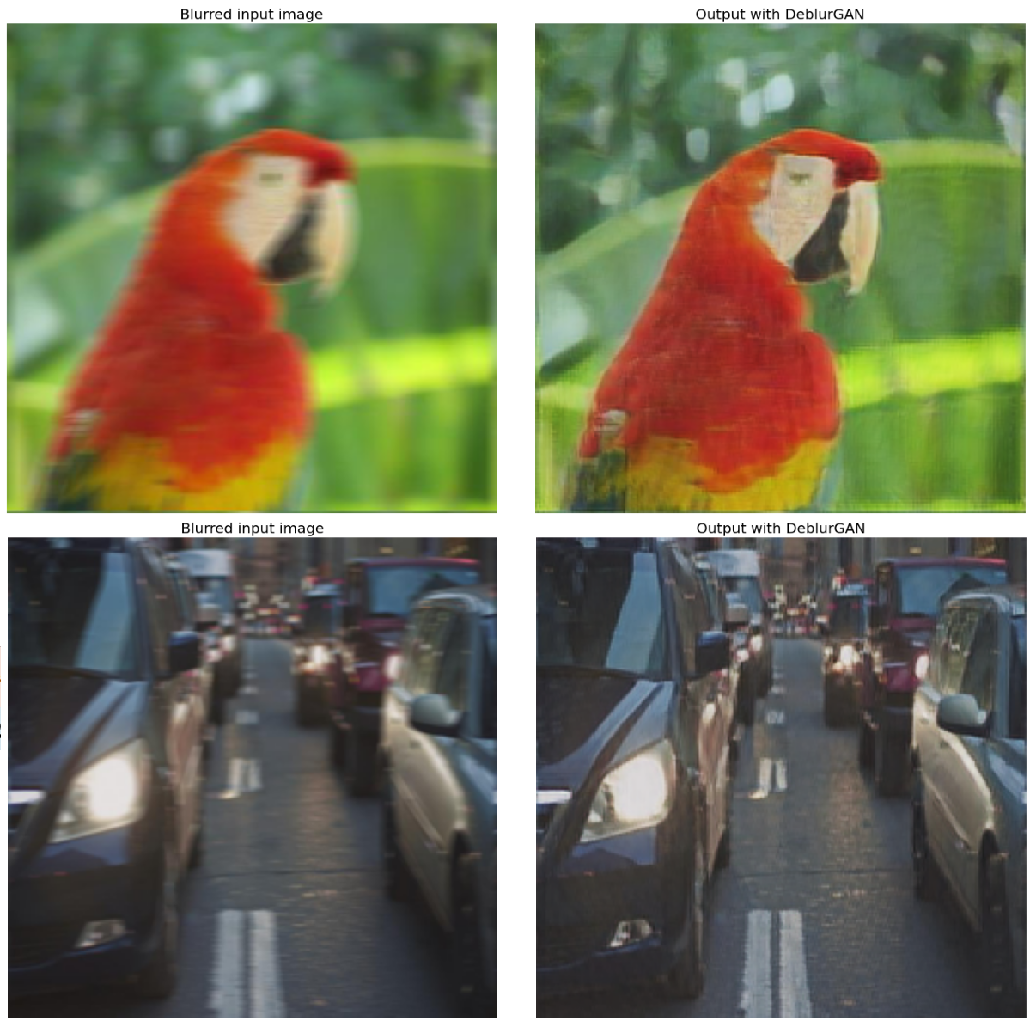

**Figure 2.11**: Deblurring images with DebulrGAN

Image inpainting

Image inpainting is a form of image restoration and conservation, and the technique is generally used to repair images with missing areas. Given an image and a (corrupted) region $Ω$ inside it, the goal of an image inpainting method is to modify the pixel values inside $Ω$, s.t. This inpainted region does not stand out with respect to its neighboring regions (surroundings). The goal of inpainting is either to restore damaged portions or to remove unwanted elements present in an input image. The region $Ω$ is provided by the user, with a binary mask (where the white/black pixels represent the damaged/undamaged part of the image, respectively, or sometimes the other way around). In this section, we shall learn how to apply a few inpainting techniques to restore the damaged parts of an input image, first using a few variational methods with the library opencv-python and then using a machine learning based method using the scikit-learn library.

Inpainting with opencv-python

There are several algorithms out there for digital image inpainting, but OpenCV natively provides implementations for a few of them, namely:

* INPAINT_TELEA: This algorithm uses **Fast Marching Method** (**FMM**) for inpainting the corrupted region in an image. The algorithm starts from the boundary of the region to be inpainted and then proceeds gradually inside the region. It first fills everything in the boundary. A pixel (to be inpainted) is replaced by the (normalized) weighted sum of all known pixels in a small neighborhood around it (nearby pixels in the neighborhood/near the normal of the boundary/on the boundary contours get more weightage). After the pixel gets inpainted, it goes to the next and nearest pixel to be inpainted, by using theFMM (by treating the region to be inpainted as level sets).
* INPAINT_NS: This algorithm is based on fluid dynamics and is called **Navier-Stokes** based inpainting. It is a heuristic-based algorithm, with couple of constraints:
  + Preserve gradients
  + Continue to propagate color information in smooth regions

**Partial differential equations** (**PDE**) are used to update image intensities inside the region with the constraints. It travels from known to unknown regions along the edges first (to maintain the continuity of the edges). It propagates image smoothness information (estimated by the Laplacian) along the isophotes (contour line joining pixels with same intensity), at the same time, it matches the gradients at the boundary of region to be inpainted.

* INPAINT_SHIFTMAP: This algorithm searches for dominant correspondences (transformations) of image patches and tries to seamlessly fill-in the area to be inpainted using these transformations.
* INPAINT_FSR: This algorithm uses **Frequency Selective Reconstruction** (**FSR**), which is a high-quality signal extrapolation algorithm. Successively, the signal of a distorted block is extrapolated using known samples and already reconstructed pixels as support. An essential feature of FSR is the fact that the calculations are carried out in the Fourier domain, which leads to a fast implementation. This further has two quality profiles, one of the them needs to be chosen, depending on how fast we need the reconstruction, they are: INPAINT_FSR_FAST and INPAINT_FSR_BEST.

In this section, we shall simply use the preceding opencv-python implementations to inpaint an image distorted by adding a random pattern. We will also carry out the following:

We shall compare the quality of the inpainted outputs obtained with different algorithms using the following two metrics, namely,

* **Peak signal-to-noise ratio** **(PSNR)**: PSNR between the original image $f$ and reconstructed image $\hat{f}$ is expressed as:

$$PSNR\left(f,\hat{f}\right)=10\log_{10}\frac{{\left(MAX\left(\hat{f}\right)\right)}^{2}}{MSE\left(f,\hat{f}\right)}$$

Here, $MAX\left(\hat{f}\right)=255$ is for a grayscale image of type uint8 and MSE is defined as:

$$MSE\left(f,\hat{f}\right)=\frac{∥f-\hat{f}∥_{F}^{2}}{s}$$

Where, $F$ represents the **Frobenius norm** of the error image matrix $\left(f-\hat{f}\right)$ and $s$ is size of image $f$ ($s=$ number of pixels). PSNR is a representation of absolute error in *dB*.

* **Structural Similarity Index Method (SSIM)**: In this perception-based model, image degradation is apprehended as perception-change in structural-information. SSIM is defined by [9]:

$$SSIM\left(f,\hat{f}\right)={\left[l\left(f,\hat{f}\right)\right]}_{α}⋅{\left[c\left(f,\hat{f}\right)\right]}_{β}⋅{\left[s\left(f,\hat{f}\right)\right]}_{γ}=\frac{\left(2μ_{f}μ_{\hat{f}}+M_{1}\right)\left(2cov\left(f,\hat{f}\right)+M_{2}\right)}{\left(μ_{f}^{2}+μ_{\hat{f}}^{2}+M_{1}\right)\left(σ_{f}^{2}+σ_{\hat{f}}^{2}+M_{2}\right)}$$

Here, $μ$, $σ$ and $cov$ respesent the mean, standard deviation and covariance of the images, $M_{1}={\left(E_{1}F\right)}^{2}$ and $M_{2}={\left(E_{2}F\right)}^{2}$, where the values $E_{1}=0.01$, $E_{2}=0.003$ and $F=255$ are used for grayscale images.

Moreover, $l$ refers to luminance (brightness), $c$ refers to contrast (range between the darkest & the brightest regions) and $s$ refers to structure (the local luminance pattern), where $α$, $β$ and $γ$ are +ve constants.

Let us dive into the following python implementation steps:

1. Let us start by importing the required libraries. Also, note the version of opencv-python (cv2)**.**

import numpy as np  
from matplotlib import pyplot as plt  
import cv2  
print(cv2.__version__)

*# 4.5.5*

1. Read the input color image and the mask image as a grayscale image (with cv::ImreadModes flag as cv2.IMREAD_GRAYSCALE which is $0$).
2. Create the binary mask for the region to be inpainted, by thresholding the mask image, by using a constant threshold (for example, $128$).
3. Create the corrupted image image_defect over the same region in each color channel, as done in the next code block.

image_orig = cv2.imread('images/house.jpg')   
mask = cv2.imread('images/random_mask.jpg', 0)  
thres = 128  
mask[mask > thres] = 255  
mask[mask <= thres] = 0  
image_defect = image_orig.copy()  
for layer in range(image_defect.shape[-1]):  
 image_defect[np.*where*(mask)] = 0

1. Let us run the preceding algorithms one after another on the corrupted image and store the recovered images in a python dictionary images_rec, indexed by the algorithm names.
2. The algorithms INPAINT_TELEA and INPAINT_NS can be accessed by the function cv2.inpaint(), whereas, the INPAINT_SHIFTMAP and INPAINT_FSR can be accessed by the function cv2.xphoto.inpaint().
3. The function cv2.inpaint() accepts the following arguments:
   1. src: the source image with corrupted/missing regions).
   2. inpaintMask: a binary mask indicating pixels to be inpainted.
   3. inpaintRadius: neighborhood around a pixel to inpaint. It is a set to $3$, because when the regions to be inpainted are thin, smaller values produce better and less blurry results).
   4. flags: INPAINT_NS (Navier-Stokes based method) or INPAINT_TELEA (fast marching based method).
4. The function cv2.xphoto.inpaint() expects an additional argument dst to store the inpainted output image. These algorithms expect the mask to have black pixels corresponding to the region $Ω$ to be inpainted. That is why we need to invert the mask since the original mask has white pixels corresponding to $Ω$.

images_rec = {}  
for algo_name, algo_id in zip(['TELEA', 'NS'], \  
 [cv2.INPAINT_TELEA, cv2.INPAINT_NS]):  
 images_rec[algo_name] = cv2.inpaint(image_defect, mask, 3, \   
 algo_id)  
  
inverse_mask = (255 - mask)   
image_rec = np.zeros_like(image_defect, dtype=np.uint8)  
for algo_name,algo_id in zip(['SHIFTMAP', 'FSR_FAST', 'FSR_BEST'], \  
 [cv2.xphoto.INPAINT_SHIFTMAP, cv2.xphoto.INPAINT_FSR_FAST, \   
 cv2.xphoto.INPAINT_FSR_BEST]):  
 cv2.xphoto.inpaint(src=image_defect, mask=inverse_mask, \   
 dst=image_rec, algorithmType=algo_id)  
 images_rec[algo_name] = *image*_rec.copy()

1. Use the functions peak_signal_noise_ratio() and structural_similarity() from the library skimage.metrics to compute the PSNR and SSIM between the original and recovered images for different algorithms.
2. Moreover, you can compute the time taken by different algorithms to produce the inpainted output (for example, use the time module).
3. Plot an output inpainted image by running an algorithm, along with the quality of inpainting reported by PSNR and SSIM values, using the show_recovered_image() function from the following code snippet.
4. Be sure to convert the image color space from BGR to RGB before displaying it with matplotlib (use cv2.cvtColor() function with cv2.COLOR_BGR2RGB argument), since the image is read with cv2.imread(), which reads the image in BGR color space by default.

from skimage.metrics import peak_signal_noise_ratio as psnr, \  
 structural_similarity as ssim  
  
def show_recovered_image(im_orig, im_rec, algo_name):  
 plt.imshow(im_rec), plt.*axis*('off')  
 plt.title('{} \n PSNR: {:.02f}, SSIM: {:.02f}'.format( \  
 algo_name, psnr(im_orig, im_rec), ssim(im_orig, im_rec, \   
 data_range=im_rec.max()-im_rec.min(), multichannel=True)), \   
 size=20)

Let us plot the original input image, binary mask, degraded image and all the recovered images obtained by running different inpainting algorithms (use the function show_recovered_image() defined previously). You should obtain a figure as shown in *Figure 2.12*. Notice that the inpainting algorithm FSR_FAST produces the best quality output in terms of PSNR and SSIM metrics:

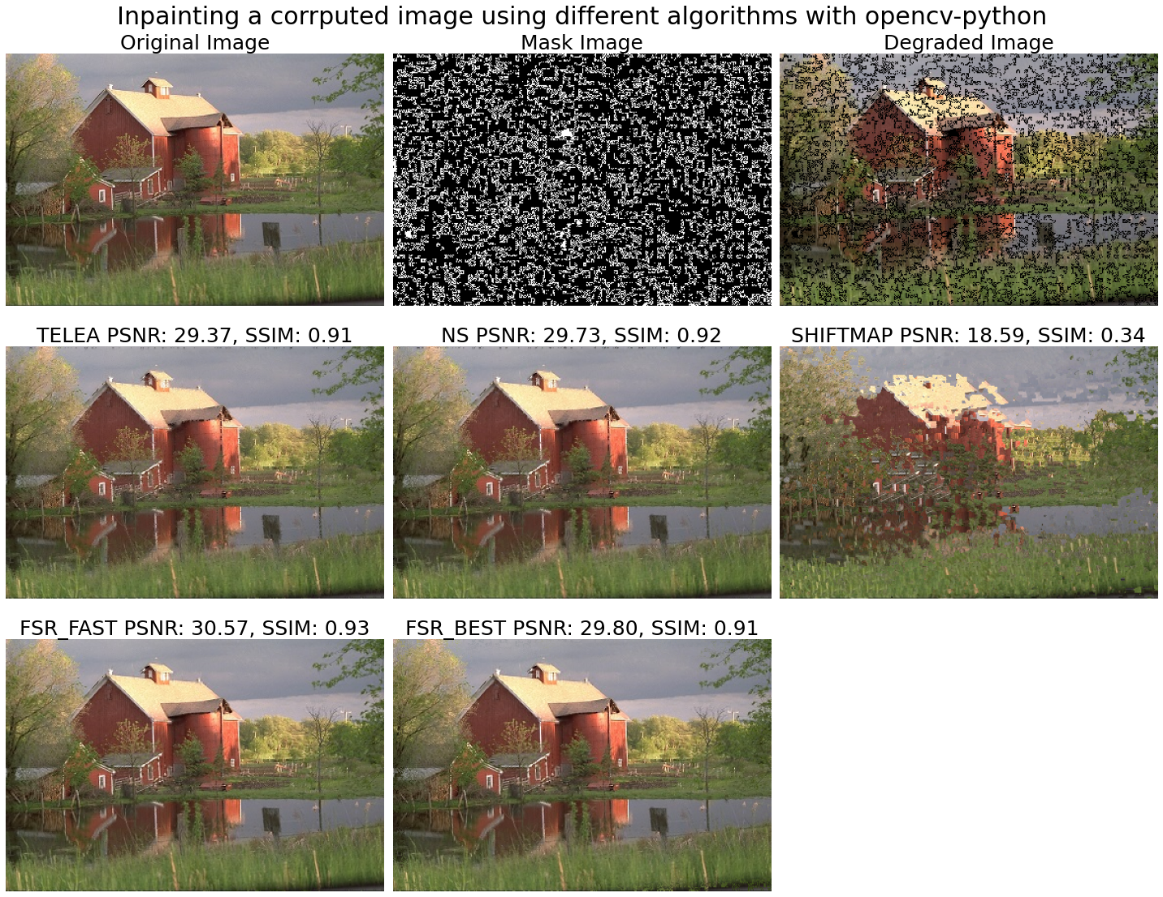

**Figure 2.12**: Image inpainting with opencv-python

Inpainting with scikit-learn k-NN regression model

In this section, we shall formulate the image inpainting problem as a supervised machine learning regression problem. More specifically, we shall try to learn an approximate function $\hat{f}$ for the image function $f:x,y→R$, by:

* Training a supervised machine learning model $M_{θ}$ that learns the function $\hat{f}$ (by updating its parameters $θ$), by minimizing a loss function $L\left(f\left(x,y\right),\hat{f}\left(x,y\right)\right)$, for $\left(x,y\right)∈Ω‾$, that is, for the region where the image is not corrupted ($Ω‾$). For example, for a model like linear regression, we can use the **sum squared error** (**SSE**) / $L_{2}$ loss function defined by $∥f-\hat{f}∥_{2}^{2}$ or equivalently the MSE obtained by dividing SSE by image size.
* Using the model $M_{θ}$ we just trained (and the function $\hat{f}$ we just learned), to predict the pixel values with $\hat{f}\left(x,y\right), ∀\left(x,y\right)∈Ω$, for the region $Ω$ to inpaint (that is, where the image pixels are corrupted).

Here, we shall use the **k-Nearest Neighbor** (**kNN**) regression model (KNeighborsRegressor from scikit-learn library’s neighbors module) to learn the function $\hat{f}$. We can use any other regression model too (for example, try the ordinary least square linear regression with MSE loss function and the ensemble model random forest regression and compare the results).

First, let us follow the next steps to create a masked image, masking the corrupted pixels that need to be inpainted:

* Let us import the required module/class and read the original input and the mask image as np.uint8 arrays, using the following code snippet.
* Note that here we are assuming that the input is a grayscale image and thus reading both the input and mask images with cv2.imread with mode flag as $0$ (that is, cv2.IMREAD_GRAYSCALE). We can extend the implementation to inpaint an RGB color input image simply by learning a model for each color channel (see exercise problem $6$).
* Threshold the mask image (with a constant threshold $0.5$, for example) to obtain a binary mask (here, the inpainting region $Ω$ is defined by the white pixels in the mask), convert it to boolean array. Assuming that the white pixels in mask define the corrupted region, let us now create the degraded image (image_defect) by turning the corresponding pixels off.

image_orig = cv2.imread('images/Img_02_05.jpg', 0)   
mask = cv2.imread('images/mask.jpg', 0)  
mask = mask / mask.max()  
thres = 0.5  
mask[mask > thres] = 1  
mask[mask <= thres] = 0  
mask = mask.astype('bool')  
*#print(np.unique(mask))*  
  
image_defect = image_orig.copy()  
for layer in range(image_defect.shape[-1]):  
 image_defect[mask] = 0

Next, instantiate a kNN regression model with **scikit-learn**, fit it on the known pixels and predict the unknown (corrupted) pixels, following the next steps:

1. First, we need to preprocess the image, so that it is suitable to be used by the kNN regression model (need to separate out the feature and the target variables). The only feature variables that we shall use here to predict a target pixel value is the $\left(x,y\right)$ coordinate of the pixel. Hence, let us generate all possible image coordinates in the grid that a pixel in the image can possibly have. This is exactly done by np.meshgrid() function, as shown in the next code snippet. Extract the pixel values for all pixels in the grid, note that the $x,y$ coordinates are swapped, can you say why?
2. Next, let us divide the image into two parts, namely training and test dataset. The training dataset (x_train, y_train, d_train) will correspond to the uncorrupted region $Ω‾$ in the image (from where the model will learn the association between the pixel value and the coordinates). In contrast, the test dataset (x_test, y_test, d_test) will correspond to the corrupted region $Ω$ (on these coordinates the trained model will predict pixel values). Here is where the Boolean mask will come in handy. Use the inverted mask and the mask, respectively, to obtain the training and the test dataset.
3. Instantiate a KNeighborsRegressor class (with default parameters) and train the model (with the method fit()) on the training dataset.
4. The kNN regression model uses the local interpolation of the *target* variable values of the kNN from the training dataset, to predict the target variable value for a test datapoint.
5. The number of neighbors $k$ to be used for prediction (n_neighbors argument in the KNeighborsRegressor class constructor) defaults to $5$. Try changing this hyperparameter (for example, to $3,7,9$) and observe the (overfitting/underfitting) impact on the inpainting result.
6. Finally, predict the corrupted pixels corresponding to the test dataset (with the method predict()). Use the binary mask array again to create an output image (image_out) with the known and the predicted pixels, this is the final inpainted image.

from sklearn.neighbors import KNeighborsRegressor  
  
x, y = np.meshgrid(range(image_orig.shape[1]), \  
 range(image_orig.shape[0]))  
d = image_orig[y, x]  
x_train, y_train, d_train = x[~mask], y[~mask], d[~mask]  
x_test, y_test, d_test = x[mask], y[mask], d[mask]  
   
image_out = np.zeros_like(image_orig)  
d_pred = np.zeros_like(d_test)  
model = KNeighborsRegressor()   
model.fit(np.vstack((x_train, y_train)).T, d_train)  
d_pred = model.predict(np.vstack((x_test, y_test)).T)  
image_out[~mask] = image_orig[~mask]  
image_out[mask] = d_pred

Now, plot the original, corrupted, and the inpainted (recovered) image side by side. You should obtain a plot like the following figure. Note that the algorithm could successfully inpaint the damaged image.

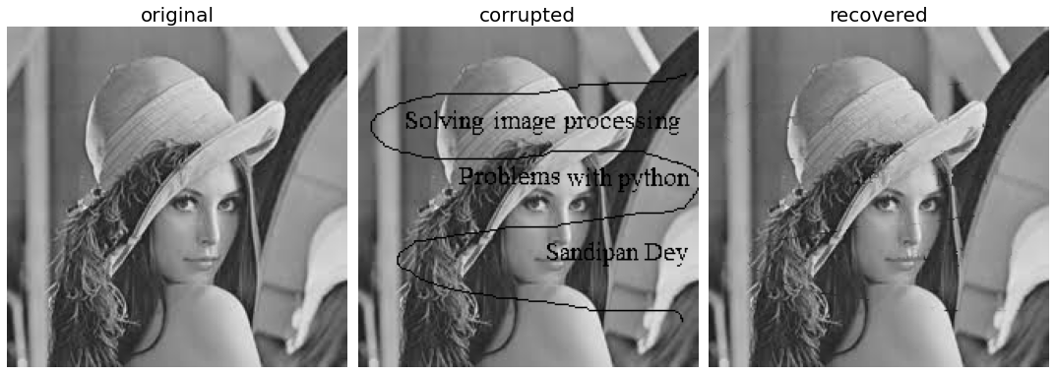

**Figure 2.13**: Inpainting a corrupted Lena image with scikit-learn kNN regressor

Image denoising with anisotropic diffusion with opencv-python

In this section, we shall learn how to use the anisotropic (heat) diffusion equation to denoise an image, preserving the edges using an extended image processing function from the library opencv-python. Isotropic diffusion is identical to applying a Gaussian filter, which blurs an image without preserving the edges in the image, as we have already seen. It refers to a uniform diffusion process where the smoothing is applied equally in all directions. This approach treats all regions of the image the same, typically leading to the even blurring of both edges and homogeneous regions.

Anisotropic diffusion, on the other hand, is direction-dependent and allows for selective smoothing. It preserves edge details by reducing the diffusion (or smoothing) across edges while allowing diffusion within homogeneous regions. This approach helps in enhancing important features like edges in images while reducing noise. The features of anisotropic diffusion are listed below:

* Anisotropic diffusion can be used to smooth (denoise) an image by keeping the edges mostly unchanged (even sharpened).
* It is anisotropic in the sense that the diffusion happens in different neighboring direction at different rates (depending on the presence of an edge or not). This is implemented by the PDE shown as follows, where the conductivity term used an edge stopping function (kernel) $g\left(.\right)$ to stop diffusion along sharp edges in the input.
* The anisotropic diffusion process is an iterative process, the Gaussian kernel or an inverse-square kernel function $g\left(.\right)$ used as a conductivity function ($c$), according to Perona-Malik *equation 1* or *equation 2* [6, 7], respectively, as shown in the following figure:

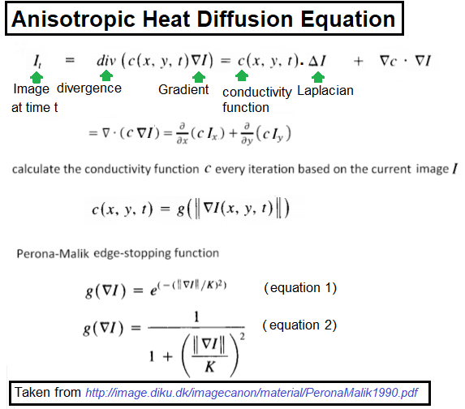

**Figure 2.14**: Anisotropic diffusion equation

Let us start the implementation by importing the required libraries, modules and functions, using the following code snippet:

import numpy as np  
import matplotlib.pylab as plt  
import cv2  
print(cv2.__version__)  
from skimage.io import imread  
from skimage.util import random_noise

*# 4.5.5*

Follow the next steps for implementation with opencv-python:

1. First, read the input RGB color image from disk and add random Gaussian noise (with a variance of $0.05$) to it, using scikit-image library’s util.random_noise() function, to obtain the noisy degraded image.
2. Apply the Gaussian blur (also can be thought of as isotropic diffusion) to the image to remove noise, using cv2.GaussianBlur() function, with the input noisy image, a tuple representing the blur kernel size ($11×11$). Set the third argument to the function to $0$ (opencv is instructed to automatically compute the variance of the Gaussian blur based on the kernel size).
3. Now let us compare the denoised output with one obtained using anisotropic diffusion performed with the function cv2.ximgproc.anisotropicDiffusion().
4. The function cv2.ximgproc.anisotropicDiffusion() applies Perona-Malik anisotropic diffusion to the noisy input image. The function accepts the following parameters:
   1. src: The 3-channel input (in our case, it will be the noisy RGB color image noisy).
   2. alpha: Time delta forwarded per iteration (typically has values in $\left[0,1\right]$).
   3. K: Sensitivity to edges in the image.
   4. niters: Number of iterations to run.
5. Use aplha=0.05 and K=30 for two different numbers of iterations, namely, $5$ and $10$ (to see how the convergence takes place at successive iterations). Play with the values of the parameters, plot the output denoised images, and observe the impact on the quality of the denoised output image (in terms of edges preserved, blurring, PSNR, SSIM).

im = *imread*('images/scene2.jpeg')  
noisy = (255*random_noise(im, var=0.05)).astype(np.uint8)  
  
plt.figure(figsize=(12,13))  
plt.subplots_adjust(0,0,1,0.95,0.05,0.05)  
plt.gray()  
plt.subplot(221), plt.imshow(noisy), plt.axis('off')  
plt.title('Noisy Image', size=20)  
output_blur = cv2.GaussianBlur(noisy, (11,11), 0)  
plt.subplot(222)  
show_recovered_image(im, output_blur, \  
 'gaussian blur: kernel=(11,11)')  
niters = [5, 10]  
for i in range(2):  
 plt.subplot(2,2,i+3)  
 output_aniso = cv2.ximgproc.anisotropicDiffusion(noisy, \   
 alpha=0.05, K=30, niters=niters[i])  
 show_recovered_image(im, output_aniso, \  
 'anisotropic diffusion: #iter=' + str(niters[i]))  
plt.show()

If you run the preceding code snippet, you should obtain a figure like the next one:

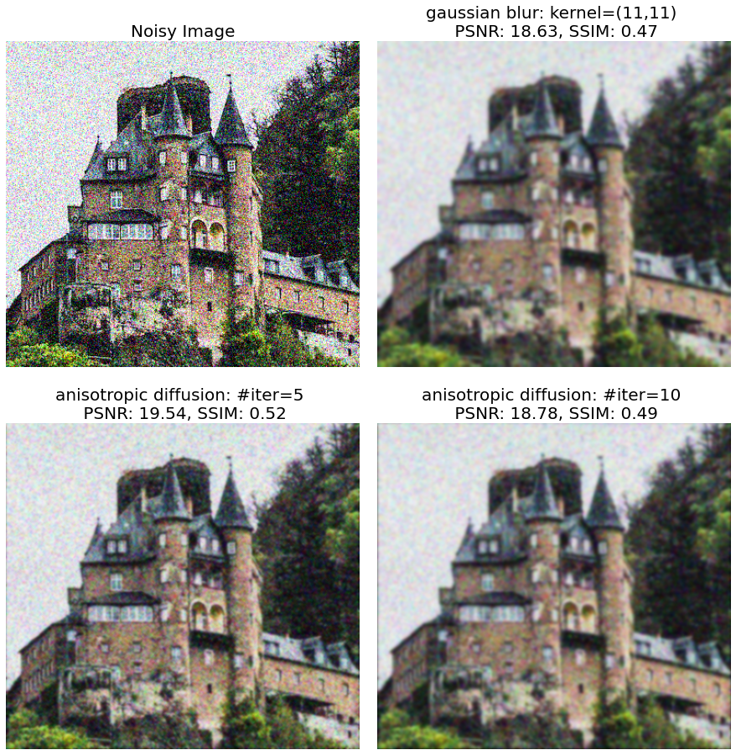

**Figure 2.15**: Denoising image with anisotropic diffusion with opencv-python

As can be seen from the preceding figure, the denoised images with anisotropic diffusion preserve edges better.

Sketch with anisotropic diffusion

Anisotropic diffusion can produce sketches from an image by subtracting the diffused image from the original image (with different iterations and varying parameter values we can get edges at different scale-space). The following code provides a simple implementation. Let us understand the implementation step-by-step:

1. This time we shall use the anisotropic diffusion implementation medpy.filter.smoothing.anisotropic_diffusion() from the library medpy (install the library first if you have not already done so).
2. Note that the input image used is a $4$-channel .png image (with an additional $α$ channel for transparency). So we need to first convert it to a $3$ channel image using the function rgba2rgb() from scikit-image’s color module and then convert it to a grayscale image (expected input for the function anisotropic_diffusion()).
3. The function edges_with_anisotropic_diffusion() computes the edges as a difference between the original and diffused image.
4. The function sketch() makes the edges more prominent (by elementwise multiplication of edges image with original image) to produce the output sketch.

Refer to the following Python code snippet:

import warnings  
warnings.filterwarnings('ignore')  
*# ! pip install medpy*  
from medpy.filter.smoothing import anisotropic_diffusion  
from skimage.io import imread  
from *skimage*.color import rgb2gray, rgba2rgb  
from skimage.filters import gaussian  
  
def sketch(img, edges):  
 output = np.multiply(img, edges)  
 output[output > 1] = 1  
 output[edges == 1] = 1  
 return output  
  
def edges_with_anisotropic_diffusion(img, niter=100, \  
 kappa=50, gamma=0.2):  
 img = gaussian(img, sigma=0.5)  
 output = img - anisotropic_diffusion(img, niter=niter,\   
 kappa=kappa, gamma=gamma, voxelspacing=None, option=1)  
 output[output > 0] = 1  
 output[output < 0] = 0  
 return output  
  
im = rgb2gray(rgba2rgb(imread('images/Img_02_09.png')))  
output_aniso = sketch(im, edges_with_anisotropic_diffusion(im))

Plot the input and output images side by side, and you should obtain a figure like the following one:

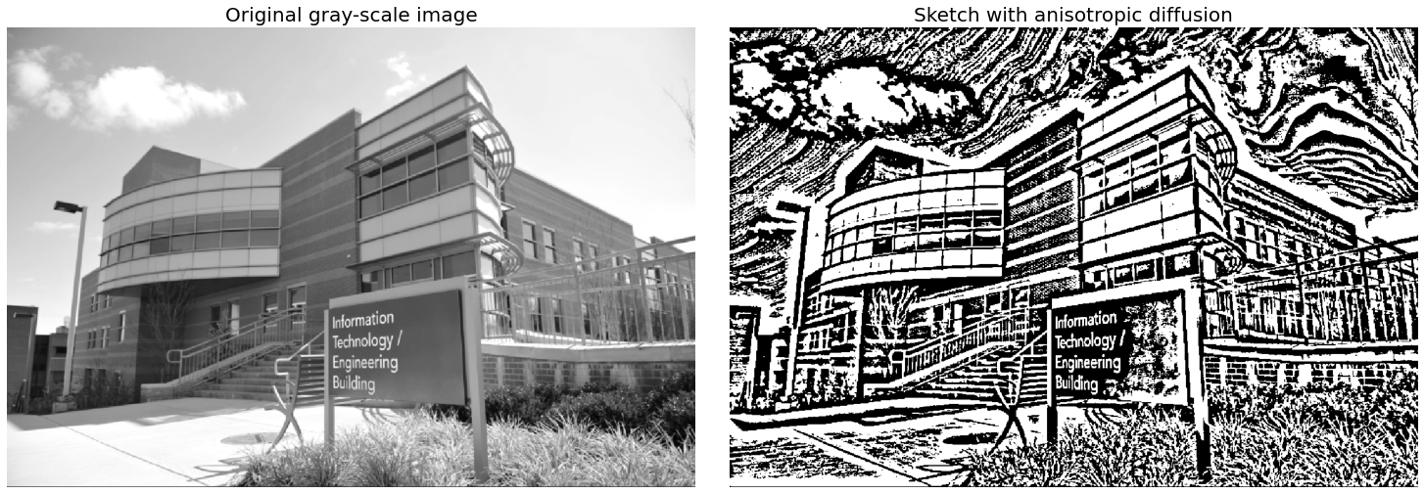

**Figure 2.16**: Sketching with anisotropic diffusion

Simple deep image painting with keras

In this section, we shall use the same idea that we used in image inpainting with supervised machine learning using deep neural network with keras. We shall reconstruct RGB values for an entire image as a function of the pixel coordinates only, $f:R^{2}→R^{3}$ and approximate the vector-valued function $f\left(\left[x y \right]\right)=\left[R G B \right]$ using a function $\hat{f}$ which will be learned from the image data with the deep neural net, using the squared-loss function $∥f-\hat{f}∥_{2}^{2}$. The reconstruction will be done by prediction with this model and we shall call this process painting the image, since it will reproduce a smooth approximation of the image, as we shall see.

Let us start by importing the libraries and modules required:

import tensorflow as tf  
from tensorflow.keras.models import Sequential  
from tensorflow.keras.layers import Dense  
from tensorflow.keras import backend as K  
from keras.utils.vis_utils import plot_model  
from PIL import Image  
import numpy as np  
import matplotlib.pylab as plt

Now, let us go through the following step-by-step implementation:

1. The function get_data() in the following code snippet extracts the feature variables $x∈R^{2}$ (pixel coordinates) and target variable $y∈R^{3}$ (RGB pixel values), to get the data ready for training.
2. The function accepts a PIL image as input, and the image data can be extracted with the method getdata(), as shown in the following code snippet.
3. Extract the r, g, b values.

def get_data(img):  
 width, height = img.size  
 pixels = img.getdata()  
 x_data, y_data = [],[]  
 for y in range(height):  
 for x in range(width):  
 idx = x + y * width  
 r, g, b = pixels[idx]  
 x_data.append([x / width, y / height])  
 y_data.append([r, g, b])  
 x_data = np.array(x_data)  
 y_data = np.array(y_data)  
 return x_data, y_data  
  
im = Image.open("images/Img_02_08.jpg")  
x, y = get_data(im)

1. The function create_model() in the following code snippet uses keras Sequential API to define the deep neural net model.
2. The network consists of a few fully connected (Dense) layers, with nonlinear Relu activation.
3. The input of the model is of dimension (input_shape) $2$ (namely, the $x,y$ coordinates of a pixel).
4. The output of the model has dimension $3$ (Dense(3)) (namely, the $R,G,B$ pixel values).
5. The loss function used is MSE (mean_squared_error), with Adam optimizer, which is defined by the model.compile() method.
6. The function generate_image() accepts the trained model as an input argument and reconstructs the same image (by predicting the pixel values with the model) of given width and height and the pixel coordinates *x*.

def create_model():  
 model = Sequential()  
 model.add(Dense(2, activation='relu', input_shape=(2,)))  
 model.add(Dense(20, activation='relu'))  
 model.add(Dense(20, activation='relu'))  
 model.add(Dense(20, activation='relu'))  
 model.add(Dense(20, activation='relu'))  
 model.add(Dense(20, activation='relu'))  
 model.add(Dense(20, activation='relu'))  
 model.add(Dense(20, activation='relu'))  
 model.add(Dense(3))  
 model.compile(loss='mean_squared_error', optimizer='adam')  
 return model  
  
def generate_image(model, x, width, height):  
 img = Image.new("RGB", [width, height])  
 pixels = img.load()  
 y_pred = model.predict(x)  
 for y in range(height):  
 for x in range(width):  
 idx = x + y * width  
 r, g, b = y_pred[idx]  
 pixels[x, y] = (int(r), int(g), int(b))  
 return img

1. Create the model and plot the model architecture using the plot_model() function, as shown in the following figure:

m = create_model()  
plot_model(m, to_file='images/model_arch.png', show_shapes=True, \   
 show_layer_names=True)

Refer to the following figure:

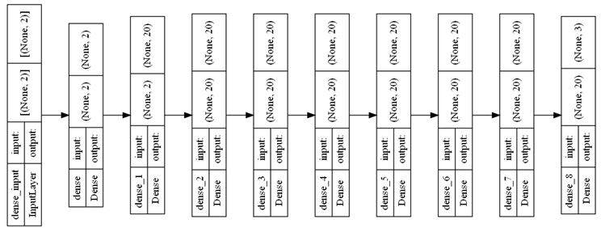

**Figure 2.17**: Keras model architecture

1. Train the model on the dataset created (using the fit() method), for $10$ epochs and with batch_size $5$.
2. Use the model trained to predict the pixel RGB values for the given coordinates. It returns the reconstructed (painted) image.
3. Plot the original input and the reconstructed output image.

m.fit(x, y, batch_size=5, epochs=10, verbose=1, \  
 validation_data=(x, y))  
out = generate_image(m, x, im.width, im.height)  
  
plt.figure(figsize=(10,10))  
plt.subplot(121), plt.imshow(im), plt.axis('off') plt.title('Original', size=20)  
plt.subplot(122), plt.imshow(out), plt.axis('off')  
plt.title('Neural Net Painted', size=20)  
plt.show()

*# Epoch 1/10  
# 61440/61440 [==============================] - 125s 2ms/step - loss: # 1449.2676 - val_loss: 1249.4037  
# Epoch 2/10  
# 61440/61440 [==============================] - 120s 2ms/step - loss: # 1041.2477 - val_loss: 647.8983  
# Epoch 3/10  
# 61440/61440 [==============================] - 134s 2ms/step - loss: # 539.8658 - val_loss: 321.4036  
# Epoch 4/10  
# 61440/61440 [==============================] - 145s 2ms/step - loss: # 361.0727 - val_loss: 332.0901  
# Epoch 5/10  
# 61440/61440 [==============================] - 120s 2ms/step - loss: # 319.6828 - val_loss: 258.9804  
# Epoch 6/10  
# 61440/61440 [==============================] - 121s 2ms/step - loss: # 299.9219 - val_loss: 260.5214  
# Epoch 7/10  
# 61440/61440 [==============================] - 140s 2ms/step - loss: # 287.6617 - val_loss: 237.3738  
# Epoch 8/10  
# 61440/61440 [==============================] - 129s 2ms/step - loss: # 275.5465 - val_loss: 272.4277*  
*# Epoch 9/10  
# 61440/61440 [==============================] - 142s 2ms/step - loss: # 269.4614 - val_loss: 253.6740  
# Epoch 10/10  
# 61440/61440 [==============================] - 129s 2ms/step - loss: # 258.9236 - val_loss: 259.6959*

If you run the preceding code snippet, you should obtain a figure like the next one:

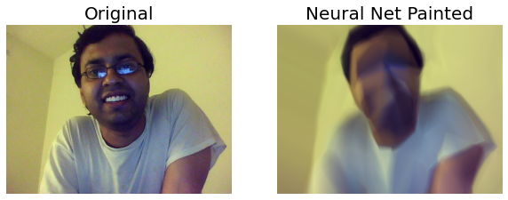

**Figure 2.18**: Neural painting with Keras

Semantic image inpainting with DCGAN

DCGAN introduces certain architectural constraints in implementing an ordinary GAN and yields better results with stronger representation learning. It eliminates the fully connected layers (and also the global average pooling which hurts the convergence speed) turning it into an all-convolutional net, replaces deterministic spatial pooling functions (such as maxpooling) with strided convolutions, allowing the discriminator and the generator to learn their own spatial downsampling and spatial upsampling, respectively.

Here are the architecture guidelines for stable DCGAN [4]:

* Use strided convolutions and fractional-strided convolutions instead of the pooling layers, for the discriminator and the generator, respectively.
* Use batch-normalization in generator and discriminator (except for the layers generator output and the discriminator input).
* For deeper architectures, get rid of fully connected hidden layers.
* For all layers in the generator, use the ReLU activation (except for the output, for which, use Tanh activation).
* For all layers in the discriminator, use the LeakyReLU activation.

The following figure shows the DCGAN generator architecture:

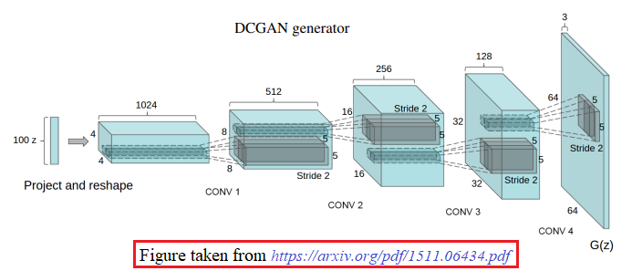

**Figure 2.19**: DCGAN generator architecture

In this section, we shall learn how to use DCGAN for image completion, given a partially corrupted image. Let us understand how we can implement it with semantic image inpainting using DCGAN:

* Semantic image inpainting is a challenging task where large missing regions have to be filled based on the available visual data.
* Given a trained generative model, the closest encoding of the corrupted image is searched in the latent image manifold using the context and prior losses. This encoding is then passed through the generative model to infer the missing content.
* The inference is possible irrespective of how the missing content is structured.
* Back-propagation to the input data is employed to find the encoding close to the provided corrupted image.
* To fill large missing regions in images, our method for image inpainting utilizes the generator $G$ and the discriminator $D$, both of which are trained with uncorrupted data. The encoding $\hat{z}$ closest to the corrupted image is recovered while being constrained to the manifold, as shown in the following figure. After $\hat{z}$ is obtained, the missing content can be generated by using the trained generator [5].

Refer to the following figure:

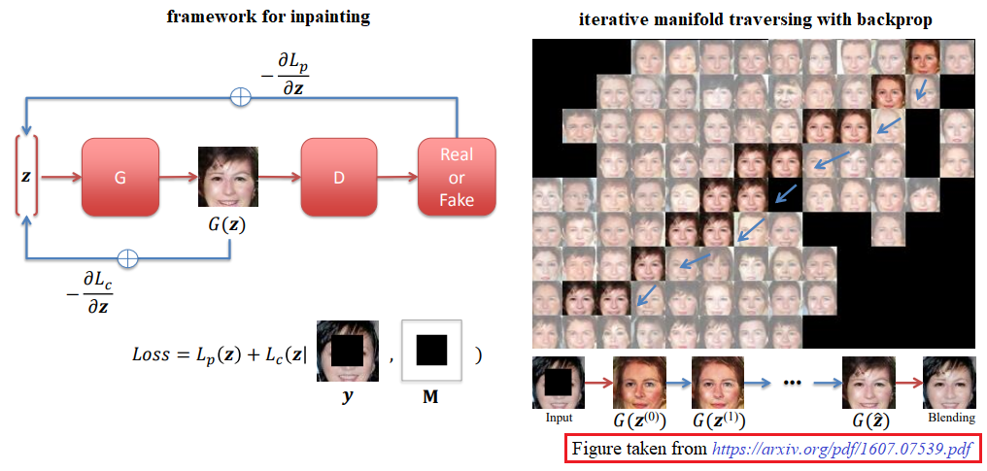

**Figure 2.20**: Semantic image inpainting with DCGAN

* The process of finding $\hat{z}$ can be formulated as an optimization problem. Let $y$ be the corrupted image and $M$ be the binary mask with a size equal to the image to indicate the missing parts. The *closest* encoding $\hat{z}$ is defined as:

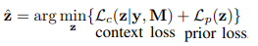

* The context loss constrains the generated image given the input corrupted image $y$ and the hole mask $M$, whereas the prior loss penalizes unrealistic images.
* **Weighted context loss**: To fill large missing regions, we need to take advantage of the remaining available data. The context loss is designed to capture such information. A convenient choice for the context loss is simply the $l_{2}$ norm between the generated sample $G\left(z\right)$ and the uncorrupted portion of the input image $y$, but such a loss treats each pixel equally, which is not desired.
* A context loss is to be defined with the hypothesis that the importance of an uncorrupted pixel is positively correlated with the number of corrupted pixels surrounding it. A pixel that is very far away from any holes plays very little role in the inpainting process. This intuition is captured with the importance weighting term, $W$ defined as follows:

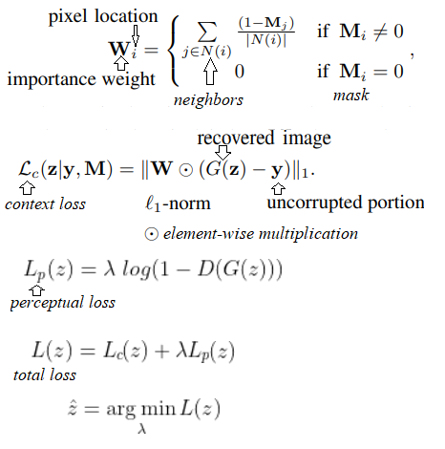

* After generating $G\left(\hat{z}\right)$, the inpainting result can be obtained by overlaying the uncorrupted pixels from the input. However, the predicted pixels may not exactly preserve the same intensities of the surrounding pixels, which is corrected using Poisson blending (by keeping the gradients of $G\left(\hat{z}\right)$ to preserve image details while shifting the color to match the color in the input image $y$. The final solution, recovered image $\hat{x}$, can be obtained by:

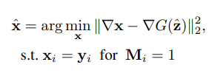

In this section, we shall use a pretrained DCGAN model with tensorflow (with v1), trained on celebrity faces (celebA dataset). Let us dive into python implementation, follow the next steps:

1. Let us start by importing the required libraries, with the following code snippet.

import tensorflow.compat.v1 as tf  
import numpy as np  
import matplotlib.pylab as plt  
from glob import glob  
from skimage.io import imread  
from scipy.signal import convolve2d

1. Read the input face images and cast to uint8.
2. Generate square masks at the center of the images using the function gen_mask(). The default input image size is $64$ and the scale is $0.25$, which determines the size of the mask.
3. Corrupt the input images by removing the central square part from the image using the masks created, by using logical AND (&) operation).

def gen_mask(img_sz = 64, scale = 0.25):   
 image_shape = [img_sz, img_sz]  
 mask = np.ones(image_shape)  
 *#assert(scale <= 0.5)*  
 mask = np.ones(image_shape)  
 l = int(img_sz*scale)  
 u = int(img_sz*(1.0-scale))  
 mask[l:u, l:u] = 0.0  
 return mask  
  
imgfilenames = sorted(glob('images/faces' + '/*.png'))  
images = np.array([imread(f, pilmode='RGB').astype('float') \  
 for f in imgfilenames]).astype(np.uint8)  
  
masked_images = images.copy()  
mask = gen_mask()  
mask = (255*mask).astype(np.uint8)  
for i in range(len(images)):  
 masked_images[i,...] = masked_images[i,...] & \  
 np.expand_dims(mask,2)  
masked_images = masked_images.astype(np.float64)  
mask = (mask / 255).astype(np.float64)

1. Load the pretrained graph from ProtoBuf file with the function loadpb(). It accepts a couple of arguments: filename (path to ProtoBuf graph definition) and model_name (prefix to assign to loaded graph node names). The function returns graph and graph_def, as per TensorFlow definitions.
2. Use the function tf.get_tensor_by_name() to access the tensors corresponding to input, output and loss in the graph object.

def loadpb(filename, model_name='dcgan'):  
  
 with tf.io.gfile.GFile(filename, 'rb') as f:  
 graph_def = tf.GraphDef()  
 graph_def.ParseFromString(f.read())  
  
 with tf.Graph().as_default() as graph:  
 tf.import_graph_def(graph_def,  
 input_map=None,  
 return_elements=None,  
 op_dict=None,  
 producer_op_list=None,  
 name=model_name)  
 return graph, graph_def  
  
model_name = 'dcgan'  
gen_input, gen_output, gen_loss = 'z:0', 'Tanh:0', 'Mean_2:0'  
graph, graph_def = loadpb('models/dcgan-100.pb', model_name)  
  
gi = graph.get_tensor_by_name(model_name+'/' + gen_input)  
go = graph.get_tensor_by_name(model_name+'/' + gen_output)  
gl = graph.get_tensor_by_name(model_name+'/' + gen_loss)  
image_shape = go.shape[1:].as_list()

1. The function create_weighted_mask() computes the importance weight mask, as defined above.
2. The function create_3_channel_mask() creates a $3$ channel mask by repeating the single channel and the function binarize_mask computes binary mask given a non-binary one.
3. The function build_restore_graph() creates the placeholders for masks and images and builds the computation graph for the context/perceptual loss and gradients. Note that since eager execution is not enabled in tf v1, the execution will only happen when a session is created.
4. The function preprocess() transforms the images and the masks prior to passing them to the model in the appropriate format.
5. The function postprocess() extracts the inpainted image from the output tensor after the execution happens.

def create_weighted_mask(mask, nsize=7):  
 ker = np.ones((nsize,nsize), dtype=np.float32)  
 ker = ker/np.sum(ker)  
 wmask = mask * convolve2d(1-mask, ker, mode='same', \   
 boundary='symm')  
 return wmask  
  
def binarize_mask(mask, dtype=np.float32):  
 assert(np.dtype(dtype) == np.float32 or \  
 np.dtype(dtype) == np.uint8)  
 bmask = np.array(mask, dtype=np.float32)  
 bmask[bmask>0] = 1.0  
 bmask[bmask<=0] = 0  
 if dtype == np.uint8:  
 bmask = np.array(bmask*255, dtype=np.uint8)  
 return bmask  
  
def create_3_channel_mask(mask):  
 return np.repeat(mask[:,:,np.newaxis], 3, axis=2)  
  
def build_restore_graph(graph):  
 image_shape = go.shape[1:].as_list()  
 with graph.as_default():  
 masks = tf.placeholder(tf.float32, [None] + image_shape, \   
 name='mask')  
 images = tf.placeholder(tf.float32, [None] + image_shape, \  
 name='images')  
 x = tf.abs(tf.multiply(masks, go) - tf.multiply(masks, images))  
 context_loss = tf.reduce_sum(tf.reshape(x, \  
 (tf.shape(x)[0], -1)), 1)  
 perceptual_loss = gl  
 inpaint_loss = context_loss + l*perceptual_loss  
 inpaint_grad = tf.gradients(inpaint_loss, gi)  
 return inpaint_loss, inpaint_grad, masks, images  
  
def preprocess(images, imask, useWeightedMask=True, \  
 batch_size=64, nsize=15):  
 images = images / 127.5-1  
 mask = create_3_channel_mask(create_weighted_mask(imask, nsize))  
 bin_mask = create_3_channel_mask(binarize_mask(imask, \   
 dtype='uint8'))  
 masks_data = np.repeat(mask[np.newaxis, :, :, :], \  
 batch_size, axis=0)  
 num_images = images.shape[0]  
 images_data = np.repeat(images[np.newaxis, 0, :, :, :], \  
 batch_size, axis=0)  
 ncpy = min(num_images, batch_size)  
 images_data[:ncpy, :, :, :] = images[:ncpy, :, :, :].copy()  
 return masks_data, images_data   
   
def postprocess(g_out, images_data, masks_data):  
 images_out = (np.array(g_out) + 1.0) / 2.0  
 images_in = (np.array(images_data) + 1.0) / 2.0  
 images_out = np.multiply(images_out, 1-masks_data) + \  
 np.multiply(images_in, masks_data)  
 return images_out

1. The function backprop_to_input() is the key function that performs the actual execution (sess.run()) on the session sess passed as an argument.
2. The function accepts the tensorflow placeholders (images, masks) and the data (images_data, masks_data) for the corrupted input images and masks.
3. The input corrupted images and masks need to be passed to the feed_dict for the placeholders.
4. The function accepts total batch_size (initialized to $64$) number of random input noise vectors z, each of dimension z_dim ($100$). It iteratively performs back-propagation through the latent manifold (runs for niter $=200$ by default) and returns the reconstructed output image imout.
5. The function restore_image() combines all using the preceding defined functions: it first preprocesses the input image/mask batch, then builds the tf graph for computation, then performs back-prop to obtain the output batch, and finally postprocesses the output to transform it to inpainted image batch, as shown in the *Figure 2.21.*

def backprop_to_input(sess, inpaint_loss, inpaint_grad,   
 masks, images, masks_data, images_data, z,   
 niter=200, verbose=True):   
 momentum, lr = 0.9, 0.01  
 v = 0  
 for i in range(niter):   
 out_vars = [inpaint_loss, inpaint_grad, go]  
 in_dict = {masks: masks_data, gi: z, images: images_data}  
 loss, grad, imout = sess.run(out_vars, feed_dict=in_dict)  
 v_prev = np.copy(v)  
 v = momentum*v - lr*grad[0]  
 z += (-momentum * v_prev + (1 + momentum) * v)  
 z = np.clip(z, -1, 1)  
 if verbose:  
 if i % 10 == 0:  
 print('Iteration {}: {}'.format(i, np.mean(loss)))   
 return imout  
  
def restore_image(images, masks, graph, sess):  
 masks_data, images_data = preprocess(images, masks)  
 inpaint_loss, inpaint_grad, masks, images = \  
 build_restore_graph(graph)  
 imout = backprop_to_input(sess, inpaint_loss, inpaint_grad, \  
 masks, images, masks_data, images_data, z)  
 return postprocess(imout, images_data, masks_data), \  
 images_data, imout  
  
batch_size, z_dim = 64, 100  
z = np.random.randn(batch_size, z_dim)  
sess = tf.Session(graph=graph)  
inpaint_out, images_data, imout = restore_image(masked_images, \  
 mask, graph, sess)

*# Iteration 0: 221.28106689453125  
# Iteration 10: 137.1205291748047  
# Iteration 20: 120.86093139648438  
# Iteration 30: 120.55803680419922  
# Iteration 40: 118.15397644042969  
# Iteration 50: 111.87590026855469  
# Iteration 60: 111.30235290527344  
# Iteration 70: 109.60200500488281  
# Iteration 80: 112.72096252441406  
# Iteration 90: 108.38629150390625  
# Iteration 100: 106.88809204101562  
# Iteration 110: 106.95480346679688  
# Iteration 120: 106.71363830566406  
# Iteration 130: 105.97818756103516  
# Iteration 140: 103.75382995605469  
# Iteration 150: 101.30975341796875  
# Iteration 160: 104.94699096679688  
# Iteration 170: 101.54997253417969  
# Iteration 180: 107.21031951904297  
# Iteration 190: 103.7147445678711*

As can be seen, the loss decreases with iteration, which means we will likely find better reconstructions for the corrupted images. Plot the original, masked (corrupted) input and the inpainted output images with the DCGAN. You should obtain a figure as shown:

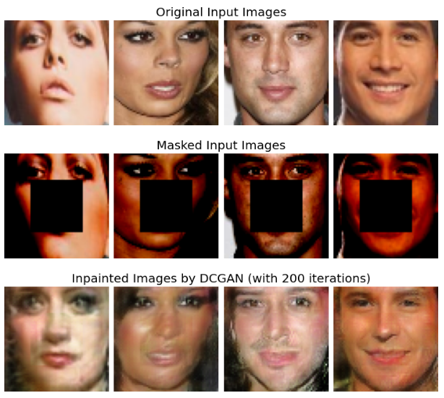

**Figure 2.21**: Image inpainting with DCGAN

Conclusion

In this chapter, we learnt a few more advanced techniques for image restoration, denoising, deblurring and image inpainting. Although we learned how to use a few variational method implementations (for example, diffusion) and a machine learning model (kNN) for image restoration, the majority of the methods we learnt to implement were based on very recent deep learning models, such as different flavors of autoencoders (sparse, variational) and GANs (DCGAN, CGAN). By now, you should be able to solve image restoration problems using deep learning pre-trained models and also write python code train models from scratch, using both the libraries pytorch and tensoflow/keras. In the next chapter, we shall start with a new and a very important topic in image processing, namely image segmentation.

Note: Throughout the chapter, we used the term parameters in a couple of contexts:

* The first one being programming context: parameters (arguments) to Python function.
* The second one in AI/ML context: learnable parameters (for example, weights and biases) for a machine learning model.

Questions

1. A very simple Blur function: Implement a python function get_custom_blurkernel() to simulate a custom motion motion-blur kernel. Implement another function gen_blurred_image() that accepts an input and an output image file and your custom blur function, reads the input image file, applies the blur kernel (by invoking the blur function passed as argument) to the input image and saves the output in the output image file. Plot the input image, the generated kernel and the blurred output image.
   1. For example, if you want to generate your blur-kernel with a cubic spline (to obtain the blur kernel used to create the blurred input for DeblurGAN), you just need to call

gen_blurred_image(path_to_input_img, path_to_save_blurred_img, \   
 get_custom_blurkernel)

And the output will look like the one shown in the following figure:

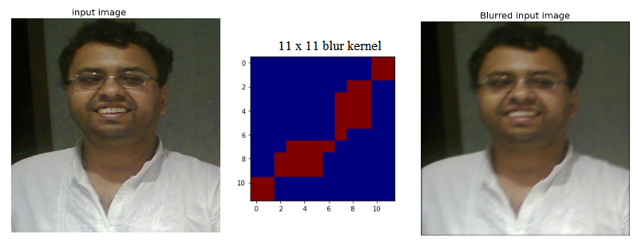

**Figure 2.22**: Blurring an image with custom blur kernel

* 1. Now, implement the motion blur kernel generation algorithm from the paper <https://arxiv.org/pdf/1711.07064.pdf>. Blur an image with the function you implemented and apply DeblurGAN to obtain the sharpened version of the image.

1. In the chapter, we used available pre-trained weights GCANet and DeblurGAN deep learning models. Now let us train the models on custom annotated images (you will need hazy/blurred and clean version of every image in the training dataset) to be used for dehazing and deblurring, respectively. Note that you can train a deep neural net model:
   1. Partially (using transfer learning), by training the weights of last few layers only (preferably when you have smaller number of annotated training images).
   2. Fully (from scratch) when you have a whole lot of annotated images.

In any case, or training a very deep learning model, you will need a *GPU* for faster training (use Google Colab).

1. Use opencv-python’s bm3d implementation (cv2.xphoto.bm3dDenoising()) for denoising (note that the algorithm is patented, you need to build opencv with an appropriate flag). You should obtain a figure like the following one:

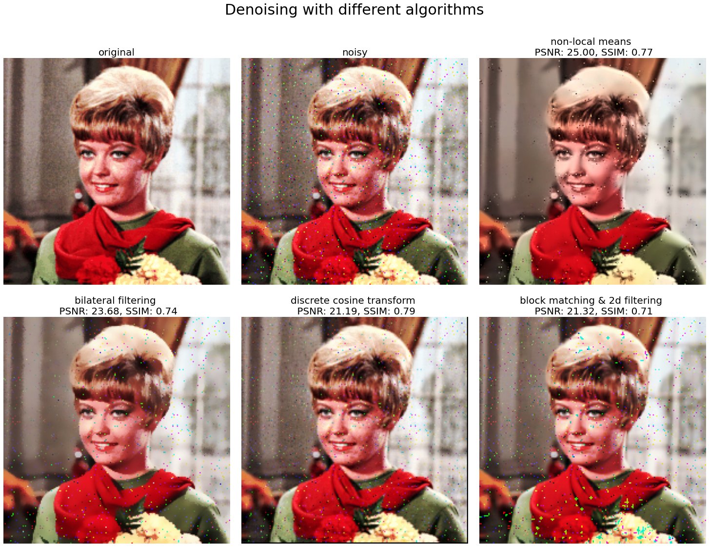

**Figure 2.23**:Image denoising with different filtering algorithms

1. Use kNN regressor to inpaint the following RGB color image with the given binary mask. You should obtain a figure like the following one:

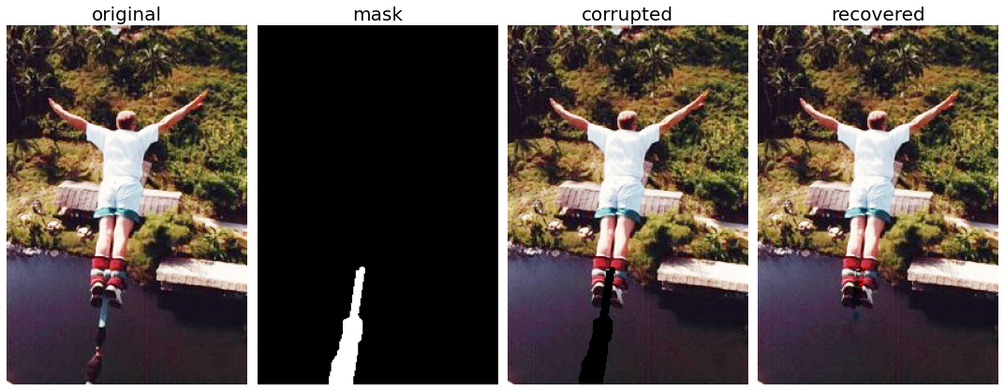

**Figure 2.24**: Image inpainting with knn regressor

Key terms

Inpainting, anisotropic diffusion, DeblurGAN, DCGAN, conditional GAN, stacked autoencoder, sparse autoencoder, kNN regression, Navier-Stokes, Fast Marching

References

1. <https://arxiv.org/pdf/1606.08921.pdf>
2. <https://arxiv.org/pdf/1711.07064.pdf>
3. <https://arxiv.org/pdf/1811.08747.pdf>
4. <https://arxiv.org/pdf/1511.06434.pdf>
5. <https://arxiv.org/pdf/1607.07539.pdf>
6. <https://authors.library.caltech.edu/6498/1/PERieeetpami90.pdf>
7. <https://aip.scitation.org/doi/pdf/10.1063/1.4887563>
8. <https://github.com/cddlyf/GCANet>
9. <https://github.com/aizvorski/video-quality/blob/d16674a14c66d9014ac82fcb7925dbc86e568d7e/ssim.py>
10. <https://www.youtube.com/watch?v=XOcCXvksbTI>